Let us have a look on Romans 8:18-27
¹⁸ For I consider that the sufferings of this present time are not worthy to be compared with the glory which shall be revealed in us. ¹⁹ For the earnest expectation of the creation eagerly waits for the revealing of the sons of God. ²⁰ For the creation was subjected to futility, not willingly, but because of Him who subjected it in hope; ²¹ because the creation itself also will be delivered from the bondage of corruption into the glorious liberty of the children of God. ²² For we know that the whole creation groans and labors with birth pangs together until now. ²³ Not only that, but we also who have the firstfruits of the Spirit, even we ourselves groan within ourselves, eagerly waiting for the adoption, the redemption of our body. ²⁴ For we were saved in this hope, but hope that is seen is not hope; for why does one still hope for what he sees? ²⁵ But if we hope for what we do not see, we eagerly wait for it with perseverance.
²⁶ Likewise the Spirit also helps in our weaknesses. For we do not know what we should pray for as we ought, but the Spirit Himself makes intercession for us with groanings which cannot be uttered. ²⁷ Now He who searches the hearts knows what the mind of the Spirit is, because He makes intercession for the saints according to the will of God.
This is a portion of the word of God of the epistle to the Romans, which Paul wrote to transmit to them some of the very basics of Biblical truth which at the same time has a deep meaning and essential teachings.
He starts saying in v.18:
“For I consider that the sufferings of this present time are not worthy to be compared with the glory which shall be revealed in us.”
There will be sufferings for the believer at this present time as there were at all the times when someone was trying to walk righteously before God and to follow Him in the Spirit. Paul is counseling the believers at that time and us also that the sufferings at this present time are not worthy to be compared with the glory which shall be revealed in us. Chapter 7 of Romans speaks in a detailed way about the difficulties someone is having while walking in the Spirit in this life and struggles with his fleshly desires. There is indeed a victory over these struggles, but our flesh is still pulling us into the opposite direction. Paul finishes chapter 7 with the exclamation: “O wretched man that I am! Who will deliver me from this body of death? I thank God—through Jesus Christ our Lord!” Romans 7:24, 25
He wanted to say that there is a victory in Jesus over the desire of the flesh which war against the desire and the leading of the Spirit. There are also other difficulties and this is that a believer in going through but all of them cannot be compared to the glory which is about to be revealed to those who believe. This is also what this portion of Romans is dealing with – with the glory and the eternal life which the believer is going to receive in heaven. We can see this in the next couple of verses.
¹⁹ For the earnest expectation of the creation eagerly waits for the revealing of the sons of God. ²⁰ For the creation was subjected to futility, not willingly, but because of Him who subjected it in hope; ²¹ because the creation itself also will be delivered from the bondage of corruption into the glorious liberty of the children of God. Romans 8:19-21
Here we see that the creation expects eagerly for the revealing of the sons of God, which is when the final judgment will be executed and the new earth and heavens will come. By the creation we mean the nature God had created which includes all animals, living creatures, plants, etc. Why does this creation expects eagerly the revealing of the sons of God and the end times when God will reign sovereignly over everything and there will be complete peace? Because this creation was unwillingly subjected to the consequences the sin brought. The sin came to the earth because of the transgression of man in the garden of Eden where he disobeyed God and ate the prohibited fruit. Since then, the sin came as a disease that spread all over God’s creation. Beside the moral decline, there was also an effect that came on all the flesh. Not only on the man, but also on the rest of the creation. The man was eternal in the garden of Eden and altogether with him, everything else. Nothing was aging, nothing was dying. Today we are so used to see everything dying and aging, that is difficult for us even to imagine that we can be eternal. It is like this because since we are born we see other people and all the creatures aging and dying. As the grass becomes yellow and then dries up, so we become white haired and then we die. Aging, dying and decomposition were some of the things that got inherited with the coming of the sin. Why do things die? Because God is not with them. He is a life-giving Spirit and everything that He is having to do with, lives. He cannot be together with the sin though; He cannot dwell with the darkness and the sin as He is the complete opposite. The man sinned and inherited sin, and altogether with that, the sin effected the entire creation on the earth, where the man lives, even though the rest of the creation didn’t sin as the man did. That’s why it is said in Romans 8:20 that the creation was subjected to futility, not willingly, but because of Him who subjected it in hope. One day also the creation will be delivered from the corruption into the glorious liberty of the children of God.
So, because of the sin God cannot live forever together with man (at least in this present sinful condition in which he is now). The only reason He gives life to man is to give him a chance. But He cannot be eternally with Him because of His nature. By nature He cannot stand at sin. It is like you, for example, when you cannot stand to see or smell something awful to you. Your nature and senses don’t allow you. Many times, it is not because you had chosen so, but because that is your particular nature. When we pass by a place with a heavy rotten smell, we automatically turn our head away, because our nature doesn’t allow us to stand it. We do not even choose it. Same is God with the sin. He cannot stand it by nature. Instead of reaching quick and take away what is not good and sinful, He decided to give us a chance by sending His Only Son to die for us so that He can pay the debt for us. This is the reason for which He had to sent Him. Because there wasn’t another way. By nature God has to let us pay the debt, to pay for our wrong, but He chose not to do so and sent His Son to die for us, He had to send Him because anyway someone had to pay for the wrong done. The Son of God did. Being innocent. That’s why His sacrifice is so powerful. This was the reason for which He came. By this we see that God has a nature that cannot stand at sin and has to place things in order. If it wasn’t in this way and God didn’t have this nature, then He could’ve simply forgotten about sin, but by the fact that He sent His son we see that someone had to pay. This was compulsory. The justice of God which is in His character and nature, required it. So for this reason He cannot dwell forever with sin and we cannot live forever in this present life. Because He cannot stay forever with the sin. We go through this life in which by the mercies of God we are given a chance after which we step into eternity with Him or away from Him.
“Then the Lord God said, “Behold, the man has become like one of Us, to know good and evil. And now, lest he put out his hand and take also of the tree of life, and eat, and live forever”— therefore the Lord God sent him out of the garden of Eden to till the ground from which he was taken. So He drove out the man; and He placed cherubim at the east of the garden of Eden, and a flaming sword which turned every way, to guard the way to the tree of life.” Genesis 3:22-24
Here in this passage we see that the Lord placed a cherubim to guard the tree of life exactly for the reason we explained before and that is that He didn’t want man to live in his sinful condition forever. The man will surely not be able to handle anyway to live forever in this present condition, as he will probably get out of his mind because of the sin which will keep on growing in him.

When Adam sinned, God told him:
¹⁷ Then to Adam He said, “Because you have heeded the voice of your wife, and have eaten from the tree of which I commanded you, saying, ‘You shall not eat of it’:
“Cursed is the ground for your sake;
In toil you shall eat of it
All the days of your life.
¹⁸ Both thorns and thistles it shall bring forth for you,
And you shall eat the herb of the field.
¹⁹ In the sweat of your face you shall eat bread
Till you return to the ground,
For out of it you were taken;
For dust you are,
And to dust you shall return.” Genesis 3:17-19
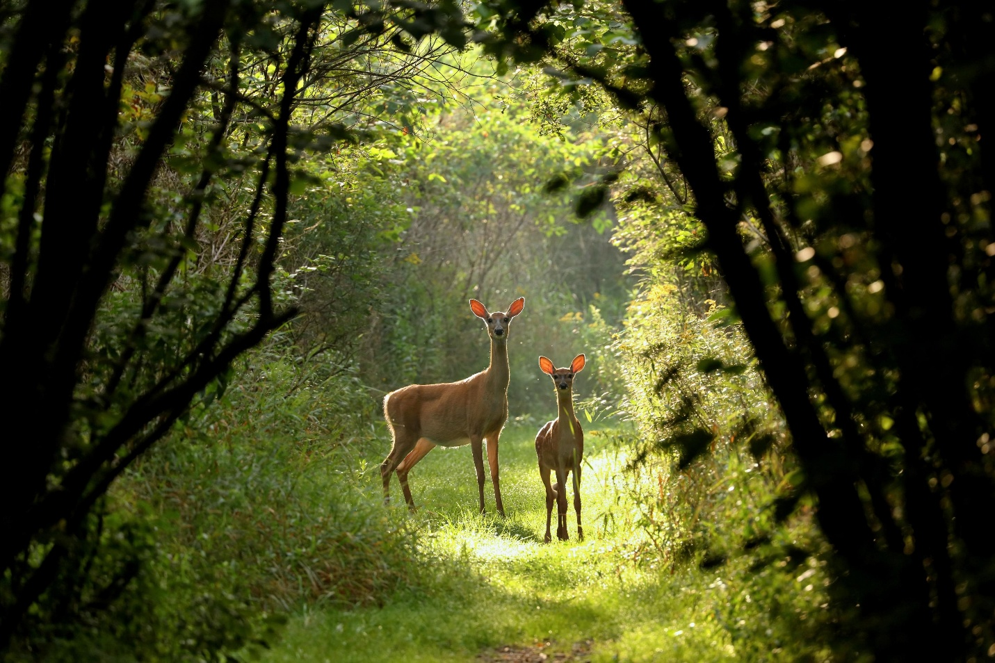
We see that the ground was cursed for the sake of man. God said that from that moment on it was going to bring forth thorns and thistles. Before probably there weren’t any of them before that. The ground was just bringing fort good fruits. We see though that in nowadays it is not so. Not only the ground was bringing good fruit only but even the animal kingdom and the creatures weren’t so fierce and hostile. It is said in Romans 8:20 that the creation was subjected to futility and corruption. This includes also the predators we see today. We can assume that in the beginning of creation, before the fall, the animals weren’t attacking and eating each other. They were given plants and fruits of the ground of the ground, same as the man. We can see it by the fact that the first time when it is mentioned and God allows the man to kill and eat an animal, is after the fall into sin. Before that we don’t see mentioned that he could feed himself with a meat. I am not saying with this that everyone should become vegetarian, I am just stating how things were established before the fall. It is not either wrong to eat meat. It is allowed as we anyway live in this world and nature corrupted by the sin. The canines such as the wolfs didn’t probably have sharp teeth and the felines sharp nails. They all could’ve developed after the failure in sin. Everything became hostile after that moment. Probably there weren’t any predators in the garden of Eden. The animals obviously didn’t sin as man did, but they were just subjected to the corruption the man brought through his failure in sin. That’s why it is said that the whole creation groans and labors with birth pangs together until now and one day will be delivered from the bondage of corruption into the glorious liberty of the children of God (Romans 8:21, 22).
Many things changed as sin effected them. This happened also with the purpose to let man perceive that not everything is fine as it seems. It is not safe now to walk in the midst of the deep nature. There might be dangers as the animals and the nature in general have tendency to defend itself. Man has lost its ability to have a dominion over the whole creation. He cannot do that with every living thing on the face of the earth anymore as God had commanded him in the garden of Eden. There are people who learn how to tame certain animals, but still they cannot do that with all of them. Nature changed after the sin as it became corrupted. We can say that the evolution for which the scientists talk about and according to them promoted the development of the kind, actually worked in the opposite way. Things changed but in worst and they degraded.
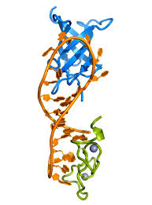
From eternal, the creation altogether with man started dying and from peaceful became fierce. All of this occurred after the fall in sin. As the grass withers so in the same way our hair grows white. One of the challenges that man is having and with which he continuously fights is aging. Man’s desire above all is to live longer here on earth and why not – to live forever if possible. Scientists are looking for numerous ways to prevent aging. Even if they manage somehow to extend human’s life, they will never be able to reach eternity here in this life, because it is established for men to die once, after which there will be a judgment (Hebrews 9:27). The eternity can be achieved only in heaven. As we said before, what changed after the fall, is that human kind altogether with all the creation started aging and dying. It wasn’t so in the garden of Eden. Do you know that there are certain genes in the human’s body that help and assist in the tissue repair and the growth as well? One of these genes is Lin28a called also “fountain-of-youth” gene. According to some scientists our gradual lost of regenerative powers may be symptomatic of a decline in Lin28a protein levels. This is why young people recover much quicker from injury than adults. Because they have it in abundance. This gene plays a vital part in wound healing and hair growth. Its decrease is the reason for which we start aging. Our cells usually separate and regenerate in this way. With time they start performing this process slower due to the lack of Lin28a protein. At certain stage of life it just starts decreasing. It is like we are programmed in this way. Scientists still don’t know why all of a sudden this event occurs. When its protein starts lacking in our body, we start aging. Scientist know this and are looking for ways to supplement or provide these enzymes, so that man can extend his life. This is really hard as they also discovered that the abundance or shortage of these enzymes could result to collateral consequences and anomalies. I am saying all this and giving an example with these genes and enzymes, so that you can imagine that it is not something impossible for a man to live forever, and how much less for God. He is the Creator of everything from the greatest creation to the least detail, including the enzymes and the genes in our bodies.
If we just had more of them we should really live longer. In Eden the human body was perfect and the whole creation also. We can assume and imagine that those enzymes were in abundance there, because God is the Creator of all these things and He had established it in this way. After the fall, this eternal part and perfection was lost, which now will be reached only in heaven, even in a more glorious form. At this moment, while we are in this life, our body arrives at a stage when it just stops regenerating due to the lack of these enzymes. This is because we are programed to live only so long and God being our Creator who knows everything, knows also the purpose for it. If we are believers, we start to regenerate and to renew at certain point and this is in our spirit and mind. The Bible speaks about it.
“And do not be conformed to this world, but be transformed by the renewing of your mind, that you may prove what is that good and acceptable and perfect will of God.” Romans 12:2 (emphasis added)
“and be renewed in the spirit of your mind, and that you put on the new man which was created according to God, in true righteousness and holiness.” Ephesians 4:23 (emphasis added)
“Create in me a clean heart, O God,
And renew a steadfast spirit within me.” Psalm 51:10 (emphasis added)
All these verses speak about renewing our mind and spirit. You notice that as the body renews (until a certain stage in this life), so our spirit renews too. See that as both are being made by the same Creator, both of them renew. The renewing of our spirit starts occurring only after we are being born again. The matter is that because we are being corrupted by the sin, it effected permanently the whole creation, and together with that our bodies. In this life they have a limit, but in the future one, in heaven they will be eternal. Our inner man, our spirit begins renewing here in this life and will reach complete perfection in the heaven, where the body will be perfect too, but with more strength and glory even than the time before the fall in the garden of Eden (1 Corinthians 15:42-49). God who is so great knows how our bodies function (because He created them) and used the same expression and explanation for our spirit, saying that if we look for Him and we seek Him, it will renew. In a way by living fully the Christian life and seeking Him, our Spirit is maintained young, even though our flesh ages. Those who hope in Him are renewing their strength and don’t get weary. This is the difference between those who hope in Him and those who do not, that those who do not, are eventually getting weary and exhausted with time. They find hope harder with each battle they face and each blow they take in life.
“Therefore we do not lose heart. Even though our outward man is perishing, yet the inward man is being renewed day by day.” 2 Corinthians 4:16
This is the verse speaking about our inward man, making a comparison with the outward man (our body). Even though it stops renewing and it gets old, we should be greatly encouraged by the fact that our inward man is getting renewed, and it will continue till the maximum of the glory when it will reach Jesus in heaven and will reach perfection. This is a real hope as we see how many people in general are getting desperate by the fact that they are growing old. Our hope is alive as we are sure that life doesn’t end up here. To know this and to believe it someone has to be convinced by the Spirit. This brings assurance in the life of the person.
In this life in which we live not only our outward man is not perfect due to the corruption and the sin but also our spirit and heart, even though we might have been redeemed, we are still living into sin, or better said, our members are still subjected to sin. We will reach a perfection only in heaven. While here we will still be struggling with sinful passions, we still need to be attentive and vigilant not to be deceived as the evil and the devil could be behind every corner waiting to devour us. We need to constantly fight with it by seeking God, dwelling into His word and in this way to keep on renewing our inner man. The difference between the Christian and the ordinary man is that the Christian fights with sin and his desire is to get into perfection, it is to change his life and not to keep on staying in the same state. He might fall but his desire will be to rise. The other persons instead when sinning, don’t feel much regret. They are in a way insensitive to it and don’t either see a reason to abandon a sin or to grow in holiness as they haven’t seen the beauty of the Lord and His holiness. The first verse of the passage we read in Romans says:
“For I consider that the sufferings of this present time are not worthy to be compared with the glory which shall be revealed in us.” Romans 8:18
Speaking about sufferings, I think that this verse refers to the sufferings us believers might encounter in this life due to the imperfections we have and the struggle with sin. Obviously “sufferings” cover a major area of events, but sin is also the reason for which believers suffer. That’s why they wait impatiently for the redemption of their body and spirit when they will be with Jesus in heaven and all transgressions, sins and imperfections will be wiped away. V. 22 and 23 say:
“For we know that the whole creation groans and labors with birth pangs together until now. Not only that, but we also who have the firstfruits of the Spirit, even we ourselves groan within ourselves, eagerly waiting for the adoption, the redemption of our body.” Romani 8:22, 23
By this passage we see that not only the creation groans and labors with birth pains but also we (the believers) who have the firstfruits of the Spirit. This means that the believers eagerly wait for their final redemption. Obviously they know that to be here on earth could bring fruit for the kingdom and will not depart till God doesn’t decide, but at the same time they also suffer because of the corruption, injustice and sin in the midst of which they are found. Of course that if a person hasn’t been redeemed by God, he will not experience this desire to be with the Lord and will not be bothered much by the sin and his sinful nature. That’s why when I speak about believers and Christians, I speak about people really being redeemed and born again, not just about someone pertaining to a religious denomination or just bearing that name. An unbeliever will never groan and suffer waiting for his redemption. Nevertheless the sufferings a believer is going through while here, cannot be compared with the glory which is to come (Romans 8:18). It is difficult for the common person to believe that there will be eternity waiting for us after this life. Some will go to eternal condemnation and some to eternal life, but this life doesn’t just end up here. It is difficult to believe in something that is not seen. That’s why Romans 8:24, 25 say:
“For we were saved in this hope, but hope that is seen is not hope; for why does one still hope for what he sees? But if we hope for what we do not see, we eagerly wait for it with perseverance.” Romans 8:24,25
We are saved in hope and hope that is seen is not hope. This doesn’t mean that who believes in Christ doesn’t feel or see anything but that the heaven and the final redemption is not yet manifested, it is not seen. Speaking about eternity and that everything we see now will perish one day it is not something easy to swallow and people don’t understand it, because it needs to be taken with faith. It needs to be believed and hoped for. Nevertheless the believers hope and groan because they have the firstfruits of the Spirit. They already experience a part of it.
The next two verses of the passage we are discussing say:
“Likewise the Spirit also helps in our weaknesses. For we do not know what we should pray for as we ought, but the Spirit Himself makes intercession for us with groanings which cannot be uttered. Now He who searches the hearts knows what the mind of the Spirit is, because He makes intercession for the saints according to the will of God.” Romans 8:26, 27
It is the Spirit of God who is helping us through thought all these difficulties and hardships we are going through in this life. Not only the common hardships but the ones having to do with our fallen nature as we spoke about. This passage is interpreted by some persons as the prayer of tongues that the Spirit is assisting us with saying that He makes intersessions for us with groanings which cannot be uttered. This is right but we can also say that in general the Spirit is helping us with any type of prayer for we many times do not know how to pray or what to pray exactly for as it is the Spirit who scrutinizes the depth of our heart and knows exactly which is our need. This means that if we are spiritual, (meaning born again) we will look for the Spirit of God and His guidance. We will obviously pray with our prayers and words but there is a time in the prayer when He starts placing words in our mouths. Then we begin discovering things that even we did not know of. The same is happening when we read His word. The Spirit is revealing it to us and in this way we see and discover things of ourselves and God that we never saw clearly before.
Glory to God as we are also having a solution through His Spirit. He didn’t leave us to face the trials in this world alone.

