In today’s days the knowledge and the science in general are been advancing in a faster way than ever before. There are discoveries new to us that we never knew before and the medicine and technology take huge steps. It looks like the man is opening his eyes to many truths around him. But there is only one truth that he still stays blinded to. This is the truth of God. The one above all the other realities and truths.
With the advance of the science there is a thought coming to the people. The thought that they don’t need God anymore and that He doesn’t fit with all of these new discoveries and new limits the man has arrived to. People now think that just by knowing something more, they hold the answers to everything and even if there are still some issues and situations that they can not get over with, they eventually will do by advancing more. This is the thought and idea of the human kind today and this is an idea of autonomy and independency. An independency from God our Creator.
But this is wrong as we were meant to be with Him and without Him we are incomplete and we perish. This is the idea that the people had in the past since the very beginnings by building the tower of Babel.
“And they said, “Come, let us build ourselves a city, and a tower whose top is in the heavens; let us make a name for ourselves, lest we be scattered abroad over the face of the whole earth.” Genesis 11:4
And exactly the same is happening now in these days. People are getting united and not in the name of God, but to show their independency and autonomy. We as human beings got over confident with our capabilities and things we’ve learned, not realizing that God is the one who actually gave us these capabilities not to be used for our own purposes, but for His glory. Capabilities that we were created with, but we eventually used for the wrong reasons, because of not having a communion with God and being blinded by the prince of this world.
Even though men see that there is always something that they are not able to fight with, that they can not overcome, they still hope that with time they will get better and will overcome it. They do that instead of looking for a solution by placing their sight in the One who created them – God the Father.
The science and the new discoveries however don’t take us away from God, I mean that they don’t actually contradict Him, but instead they just confirm His existence and His greatness if looked in the right way. It is true that people in the past used to explain many things happening around them with God’s presence and today we have many different explanations, but those people were actually right. They used to explain it in a simple way, because they were simple and didn’t have the knowledge we have today. Today we can also explain God’s truth even in a more detailed and complex way, because we have more knowledge. More knowledge about science and more knowledge about the Bible. In todays days we’ve got His complete word – the Bible and many of us can possess it easily. We can do that instead of joining the others in doubting and questioning the truth, thinking that the new discoveries and new perspective of human knowledge and science contradict God. They contradict it, because we contradict Him. It is a question of how we see it, from which point of view we see it. If we want to hide the truth we will use each reason and pretext to do it, but if we want to see it, we would just admit it. There is a wrong way to look at science and a false science and there is also a right way to look into it.
“O Timothy! Guard what was commited to your trust, avoiding the profane and idle babblings and contradictions of what is falsely called knowledge – by professing it some have strayed concerning the faith. 1 Timothy 6:20,21
We see here in this verse Paul warning Timothy about what is falsely called knowledge. This is the knowledge that is actually being corrupted by our carnal mind which is influenced by sin and by nature doesn’t believe. We can say that speaking about knowledge, this verse refers also to the science of our days, because science is obviously having to do with knowledge which is systematically organized on a certain subject.
Today we also can explain God’s existence by the things we got to know in the science for example, instead of hardening ourselves and using that knowledge to contradict Him. The people in the past used to explain most of the things happening around them and natural events with God’s intervention and today we know so much about how things are formed, how the elements and molecules join together and we think that that’s why things happen, but we still don’t know who commanded them to join in this way and who gave them that energy and strength and form. Nothing that we see is there by coincidence. We can see perfect forms, perfect shapes. We can see a beauty in the nature and a design standing behind it. And this doesn’t happen by coincidence or an accident. And we still can’t explain most of this. Scientists don’t have exact answers to this.

- God is faithful with the least of the details
Persons and scientists having discovered something new in the most miniature and microscopic way, actually confirm how God cares about the least of the details. He is involved even in the smallest things.
“He who is faithful in what is least is faithful also in much; and he who is unjust in what is least is unjust also in much.” Luke 16:10
This is what He says that we as persons need to do – to be faithful in what is least, but He is the one that actually is doing it first. All the things He is telling us to do are because He is like this, He is doing those things. If for example He tells us to be righteous, it is because He is righteous, if He tells us to love, it is because He loves. Same, if He tells us to be faithful with the least things, it is because He is faithful and mindful of the least of the details.
“Are not two sparrows sold for a copper coin? And not one of them falls to the ground apart from your Father’s will. But the very hairs of your head are all numbered.” Matthew 10:29,30
His mind is so huge and great. He cares about us, who are also being so little and small compared to all His creation.
- The clever way with which we are made
When someone discovers a new planet or a solar system or galaxy, he doesn’t proof anything against God, but on the contrary, he just shows how great is our God, as great as the universe and even more, because He created it. All of these scientific discoveries don’t proof anything against God, because He stays behind all the things we are surrounded with and the discoveries just confirm His perfection. He knows about the chemical reactions, about the molecules and the atoms, about how our body is made and how our organs function. He knows the way our brain works and sends signals to the rest of our body. He knows it, because He created it.
Psalm 139:13-16 says:
“For You formed my inward parts; You covered me in my mother’s womb. I will praise You, for I am fearfully and wonderfully made; marvelous are Your works, and that my soul knows very well.
My frame was not hidden from You, when I was made in secret, and skillfully wrought in the lowest parts of the earth. Your eyes saw my substance, being yet unformed. And in Your book they all were written, the days fashioned for me, when as yet there were none of them.”
Today we know the complex way in which we are made. There are things and parts of our body structure and organs like the brain for example that haven’t been fully explained and discovered by the scientists. But still the psalmist said in that time that we are “fearfully and wonderfully made”. This perfect machine, this perfect structure as our body was fashioned by our Creator in secret, in the lowest part of the earth. He formed our inward parts to the least detail. Today scientists are discovering how our body works and functions, but our creator already knew all of this a long time ago, because He formed it. We can only see how perfectly it works. Everything there is with a purpose.
Somebody can say that by instinct our body and the other living organisms protect themselves and live and learn to survive, but who actually gave them that? Who gave them this intelligence? Because this is an intelligent process that occurs in the living organisms and it doesn’t happen by an accident. It is not a fruit of it. When our body detects a virus or something foreign in its system, it automatically fights it and sends white blood sells to protect it. This is something intelligent, something logical. We see that we are made in a clever way. Why? Because the greatest mind of the universe stands behind it.
There are natural barriers and an immune system that are designed to defend our body from foreign organisms that can cause an infection. Natural barriers include the skin, mucous membranes, tears, earwax, mucus, and stomach acid. There are white blood cells and antibodies used by our immune system to identify and eliminate organisms that get through the body’s natural barriers. We see the way we are created. The most perfect machines today can not match with our body.
- The atoms and the solar system
We can see the creation and the perfection with which God did it, to the smallest detail as well. The structure of an atom for example. The atoms altogether form a molecule. Everything created and the nature in general (the one undefiled by man) is placed there in a perfect order.
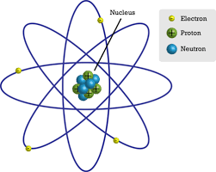
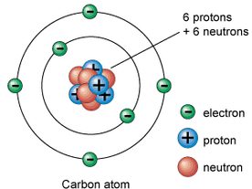
Looking at the universe as well, we see that stars, planets, a solar system are placed perfectly in a specific way. It has nothing to do with an explosion or just throwing all the things there in a chaos. Somebody with a mind having a design stands behind it. Even if we go to the smallest details microscopically speaking, we will see molecules, atoms and all other small particles placed in order that is also very similar to how a solar system works - it explains that the same mind stands behind it. Each molecule is composed by atoms that hold each other. These pictures above show the structure of an atom. There are different kinds of atoms, but almost all of them are composed of neutrons and protons that form the nucleus and electrons that circle around it in a very similar way as planets do around the sun. And if I am not mistaken, there are cases where each electron is having its own and unique orbit same as the planets. The pictures below instead, show a solar system.
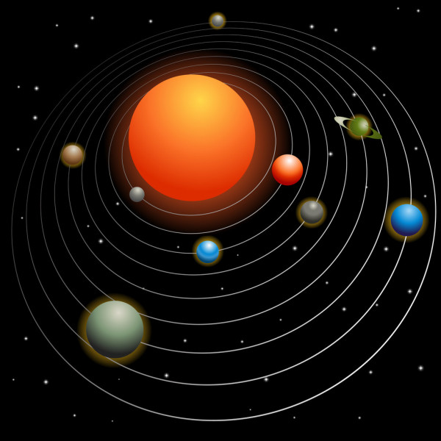
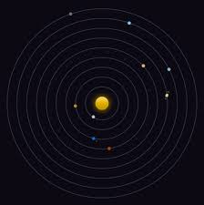

We can see similarity here with the atoms which in their structure look like a mini model of what a solar system is. I am not saying that the atoms are small solar systems, but just that by the way they are made, we see God’s genius design and creation, we see that the same mind has created all of them, from the smallest to the greatest detail.
Again we see that the advancement of the science does nothing else, but proving God’s design and creation. And I think that more we discover, more we dig into us or into what is surrounding us, we will constantly see something leading us again to Him. People just don’t want to admit it and invent all bunch of theories, just because they don’t want to see it and admit God’s existence. We see that the heart of man hasn’t changed throughout the years. It is always the same. As before they were finding reason not to believe and follow God, so they do now. A miracle is needed to change that heart which by its nature flees away from Him. “To believe” in itself is a miracle. It is a gift from God that we need to desire. It is having to do with His death on the cross and resurrection. Jesus gave us an opportunity to receive it with His death on the cross.
- The universe had a beginning
There is another discovery about the universe and it states that the universe is expanding. It was announced first by Edwin P. Hubble, an American astronomer. He demonstrated that the galaxies visible from the Milky Way all seemed to be speeding away. For the universe is also discovered that is spinning. All this shows that the universe had a beginning. Obviously, as the people and scientists can not explain it exactly, they find theories like the “big bang”, but there still can not be found exact proofs for that. Someone needs to imagine it and in a way, believe in this theory, I mean that it takes faith to believe in God and it also takes faith to imagine the big bang. Which one do we prefer? Which one is really proved by the science? Difficult to answer, if we really look at the facts, logically speaking. We instead know and have faith that was God, by the power of His word who created all the matter, everything we see and everything we can not. The universe had a beginning, because God set that beginning. “In the beginning God created the heavens and the earth.” Genesis 1:1
We can also see some verses speaking about how He stretched the heavens.
“He alone spreads out the heavens, and treads on the waves of the sea; He made the Bear, Orion, and the Pleiades, and the chambers of the south;” Job 9:8
It says that He “spreads out” the heavens. This was written years ago before the scientists discovered that the universe is expanding. Saying all of this, I am not opposing myself to the science in general, on the contrary, it could be a method that can proof in a way that God is real. I am opposing the unbelief in general and every thought that rejects God’s truth. But this is the human thought in general. We don’t want to admit that God is there. It is in the human nature. In mine, in yours, in everyone’s. The only way to fight it, is through faith and trying to humble ourselves by admitting what we are, by admitting our faults.
“Thus says the Lord, who created the heavens and stretched them out, who spread forth the earth and that which comes from it, who gives breath to the people on it, and spirit to those who walk on it:” Isaiah 42:5
“He has made the earth by His power; He has established the world by His wisdom, and stretched out the heaven by His understanding.” Jeremiah 51:15
“The burden of the word of the Lord against the Lord, who stretches out the heavens, lays the foundation of the earth, and forms the spirit of man within him:” Zechariah 12:1
All of these verses speak about how He stretches out the heavens. That’s why the universe expends. Obviously when we speak about the heavens in the Bible, we speak about everything above us and the stars and the universe. We know that in that time obviously they were not using certain terminology as we do today. Yes, there is an energy all around us and that’s why things happen, but why this energy and where it comes from? We know what causes certain reactions and things to happen in the nature and on scientific level, but we don’t actually know the main cause and what stands behind it. There is not an explanation for that. But the answer is that God stands behind all of this. He is all over.
“God, who made the world and everything in it, since He is Lord of heaven and earth, does not dwell in temples made with hands. Nor is He worshiped with men’s hands, as though He needed anything, since He gives to all life, breath, and all things. And He has made from one blood every nation of men to dwell on all the face of the earth, and has determined their preappointed times and the boundaries of their dwellings, so that they should seek the Lord, in the hope that they might grope for Him and find Him, though He is not far from each one of us; for in Him we live and move and have our being, as also some of your own poets have said, ‘For we are also His offspring.’” Acts 17:24-28
We see from this verse that He is everywhere, that in Him we live and move and have our being. He is in everything and every detail happening around us.
- Facts that the Bible stated before the science did
“He stretches out the north over empty space; He hangs the earth on nothing.” Job 26:7
Here in this verse found in one of the most ancient books written ever in the Bible we see that it states that He hangs the earth on nothing. How could they understand this in that time, if the common believe was that the earth was flat or that the earth stands on something? There were many ideas and mythologies at that time stating that the earth stands on something. The Bible instead was one of the first saying that the earth is actually hanged on nothing in the space. Today we also know by the discoveries that the astronomy has made that the earth is having its own orbit and is hanged on nothing. As we see, this truth was written in the Bible long ago before astronomy had advanced to discover that the earth is hanged in the space on nothing. We see again that the Bible doesn’t contradict the science. It contradicts it only in the area where they reject God’s existence.
Something else that we can notice from the creation is the variety of fruit that the earth produces and all of those which are edible, are having some benefit for our body. We can see fruits, vegetables, plants that help to maintain our health system. Each edible fruit and plant consumed by us, is there for a purpose. It is like there is no coincidence at all. Scientist now have discovered what kind of benefits each plant and fruit are having for us. This is just revealing God’s genius design standing behind it. He created everything with a purpose. God says in His word:
“And God said, “See I have given you every herb that yields seed which is on the face of all earth, and every tree whose fruit yields seed; to you it shall be for food.” Genesis 1:29
Another fact that we see biblically expressed is the verse in Leviticus 17:11
“For the life of the flesh is in the blood, and I have given it to you upon the altar to make atonement for your souls; for it is the blood that makes atonement for the soul.”
We can see this verse stating that the life is in the blood, written a long ago before it was officially accepted by the medics. Today we know that the blood in our body transports oxygen and nutrients to the lungs and tissues, it carries cells and antibodies that fight infection, it brings waste products to the kidneys and the liver, which on their side filter and clean the blood and it forms blood clots to prevent excess blood loss.
The life is in the blood ad that’s why Jesus shed His blood for us, to cleanse us from our sins. What we need to do is to believe it and accept it by acknowledging our limits, our weaknesses and our faults as human kind and personally in our lives. Without this we will be wandering around trying to find answers for the meaning of everything, but we will always end up without a satisfaction. More we discover, more we advance, there will be always something that will point us back to God, saying that the answer is there. More we try to avoid it and turn away, more we will pay the consequences of our own negligence toward it.
We need to meditate on this. Maybe some of the scientific facts that I mentioned here are not perfectly accurate and are not in the way that someone else might be thinking, but in general this is an invitation for all of us to meditate and to look for the answers in God and believe Him, because what is true is that many times people purposely want to put God aside and are looking for all the excuses possible, when actually His absence can not be proven. Someone can say that His existence can not be proven (it is by faith), but actually neither His inexistence can be. His creation testifies of Him and His character. He also cares for us. We are not without a purpose. We live as ones, but finding Him, we find the real purpose for us.

