“And I saw in the right hand of Him who sat on the throne a scroll written inside and on the back, sealed with seven seals. Then I saw a strong angel proclaiming with a loud voice, “Who is worthy to open the scroll and to loose its seals?” And no one in heaven or on earth was able t open the scroll, or to look at it. So I wept much, because no one was found worthy to open and read the scroll, or to look at it. But one of the elders said to me, “Do not weep. Behold, the Lion of the tribe of Judah, the root of David, has prevailed to open the scroll and to loos its seals.” And I looked, and behold, in the midst of the throne and of the four living creatures, and in the midst of the elders, stood a Lamb as though it had been slain, having seven horns and seven eyes, which are the Spirits of God sent out into all earth. Then he came and took the scroll out of the right hand of Him who sat on the throne. Now when He had taken the scroll, the four living creatures and the twenty-four elders fell down before the Lamb, each having a harp, and golden bowls full of incense, which are the prayers of the saints. And they sang a new song, saying:
“You are worthy to take the scroll, and to open its seals; For You were slain, and have redeemed us to God by Your blood out of every tribe and tongue and people and nation, and have made us kings and priests to our God; and we shall reign on the earth.”“ Revelations 5:1-10
In this passage of Revelations we see that John, the one who received the revelation wept much, because there wasn’t found anyone worthy to open the scroll. None in heaven or on the earth, or under the earth. Now, we know that there were many extraordinary men in the whole Bible, men that gave us example with their constancy, faith and life, but none of them was found worthy as well to open the scroll in heaven. Beside one – the Lamb of God, that is Jesus Christ. The same one that is represented as a Lion in v.5. This is how He really is – as a Lion. And in the next chapters of Revelation we see that each opened seal represents a judgment on the earth. So, here we see that Jesus is actually involved in the final judgment. Not only involved, but we can see that everything is going to be judged through Him. He is Alfa and Omega. The beginning and the end. Everything started trough Him and is going to be finished trough Him.
John 5:22 says: “For the Father judges no one, but has committed all judgement to the Son.“
Acts 10:42 “And He has commanded us to preach to the people, and to testify that it is He who was ordained by God to be judge of the living and the dead.“
We see that God has appointed Jesus to be judge upon everything. But why is He worthy to open these seals and to judge? We see throughout the whole chapter of Revelations 5 that more than once He is been mentioned as a Lamb and we see them often saying “worthy is the Lamb“. As a Lion He is mentioned once, but the reason why He is worthy of all the praise and to open the scroll with the seals is because He was the Lamb that was slain. His sacrifice made Him worthy and above everything. So effective to save, but also to judge at the final day. Obviously He was worthy also before that and is always been, but this sacrifice accomplished God’s righteousness regarding our situation and God needs to accomplish everything in the right way.
He can judge because through His sacrifice He gave opportunity to people to be saved. He doesn’t want to judge before giving us opportunity. He could, but He is so just, that He wants to give us a chance first. He wants to give it to everyone. This is His desire. No one will have an excuse. No mouth would open at that final day after seeing the greatness of His sacrifice. In front of this greatness no one could say, as we often say today that something is not fair or just. That’s why He is mentioned more than once as a Lamb in this chapter. And as a Lamb He opens the seals that represent the judgment. Because of what He did for us on the cross is that He is worthy. That’s why the Father wants everyone to hear the good news, so that everyone could have the opportunity. He could judge us also as we are, but in His justice and love He decided to look unto us.
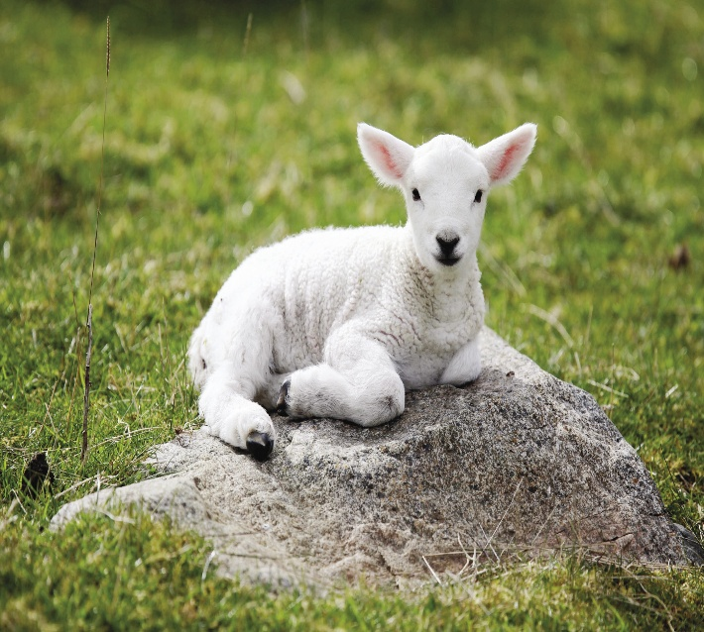
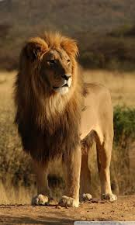
“For by Him all things were created that are on earth, visible and invisible, whether thrones or dominations or principalities or powers. All things were through Him and for Him.“ Colossians 1:13
We can clearly see through this scripture and many others that Jesus is in the center of all. Everything started through Him and it will finish as well through Him. It is interesting to notice something in the parable of the barren fig tree in Luke 13:7 “Then He said to the keeper of His vineyard, ‘Look, for three years I have come seeking fruit on this fig tree and find none. Cut it down; why does it use up the ground?’“
What we know from this parable is that the owner of the vineyard is the Father and the keeper is Jesus. And the tree could be anyone of us. We see that the father commanded the keeper (the Son) to cut the tree. It means that He will be the one performing that action – to cut. Meaning the judgement. And He was the one showing mercy and giving another opportunity to the tree to bear its fruit. Opportunity that all of us have been given through His sacrifice. A special treatment for our life to be able to bear fruit. His sacrifice and His blood are that kind of treatment. That’s why He was considered worthy to open the seals. Because He gave us opportunity. We don’t have an excuse in front of this. No one will dare to open his mouth one day in front of this truth. Everyone will come to an acknowledgement of what His sacrifice really represents. Better for us is to acknowledge it today.

God is patient toward us, that’s why the end of everything hasn’t come yet. It is through His sacrifice that He still gives us opportunity. But the patience and the opportunity can also run out. And all the people will have to face anyway the judgment in one way or another. Because all of us will finish one day their life.
“But the heavens and the earth which are now preserved by the same word, are reserved for fire until the day of judgment and perdition of ungodly men.“ 2 Peter 3:7
Here in this passage we see Peter prophesying and speaking about the judgement and in 2 Peter 3:9 states that the Lord is longsuffering toward us. But there is a reason why. It is because of Jesus. In the verse above says that the heavens and earth are preserved by the same word, the one with which everything was created. And that word is Jesus. That means that He is the one who withholds, prevents the judgement of happening and He is the one that will release it. How many times He withheld it already from our life? (At least from mine). How many times we deserved something else and He instead gave us opportunity?
He is a Lion and a Lamb. He came as a Lamb to suffer and didn’t strike back, He was humble all the way. But one day He will come back as a Lion. Coming as a Lamb anyway was what made Him worthy and accomplished God’s justice. (Obviously He was already worthy and He’s always been, but coming as a Lamb helped us to understand that He is worthy, because this was the way that He reached us and saved us.) Through His sacrifice heaven’s gates were opened for us. Something like dying on a cross, that was considered so less and so weak by man, became the center of everything and our salvation. He was already worthy, but dying on the cross was what reached us, opened our eyes to see His glory and helped us to acknowledge Him.

