Many people in this world have questions about life, the reasons for it, and about God. We will never be able to explain everything or find the exact answers we are looking for, but I believe we will find enough for us to decide, to take a stand. Before finding some answers, we mustn’t rush with making a decision, especially the wrong one. We find as well that certain things are unexplainable. And we will find answers only when we stand in front of Him, who holds all the secrets since the foundation of everything. I believe He wants us to know enough so that we are able to take a stand, and He only knows how much that “enough” is for us.
Many people have questions about God and why He is doing things in a certain way. Some of them create their own image of Him and believe they know most of Him already. No one actually knows so much about Him. Some people know just enough, but there is always more to discover. Thinking that we know or have an idea of who God is without having Him really in our life can lead us to dangerous prejudices.
Who is God, and why is He working in such a way?
This is a very hard, complex question that obviously all the world’s books cannot answer. But I’ll try to write shortly from what I understood by personal experience that obviously doesn’t give a complete answer as God is so huge and great we cannot even imagine. What is important is that our opinion and idea of who He is, go toward the right direction that is always accompanied and confirmed by His Word. There we find the revelation of God for us, and there we can be taught about Him. We must base our opinions and thoughts about Him on what we find there.
Often the way we and most people imagine God might be erroneous, as we haven’t arrived yet in a certain level of understanding. For the natural man, the one who doesn’t know God, this is normal. His knowledge of Him is superficial, mainly from what he had heard of Him. The spiritual person who has been reborn and now is a new creation in Him is still the same. He doesn’t have complete knowledge of Him yet as he will have to learn more all his life. Still, at least he has a foundation to build on. This is still a small, but true part of God’s glory, revealed to him, because one day he had the experience of repentance and have truly known God’s forgiveness. The knowledge we are speaking about is not just a theological knowledge, but one the Holy Spirit teaches in our hearts. Then after having that, we can also know more, theologically speaking. The theological knowledge must always go hand in hand with the spiritual one.
Many people wonder why God works in a specific way, why He acts with such a way toward sin, and why He is holy and cannot bear sin. We add His judgments to the discussion as there are often misunderstandings regarding this topic.
Let’s see a verse in the first letter to the Corinthians 14:33
“For God is not the author of confusion but of peace, as in all the churches of the saints.”
And 1 Corinthians 14:40 says “Let all things be done decently and in order.” Apparently, this verse in its context speaks about having an order in the churches about prophesying and speaking in tongues. And so it is. But the verse itself reveals the character of God and His nature. And there are other verses in the Bible speaking about the same topic. So here we can see the way He is.
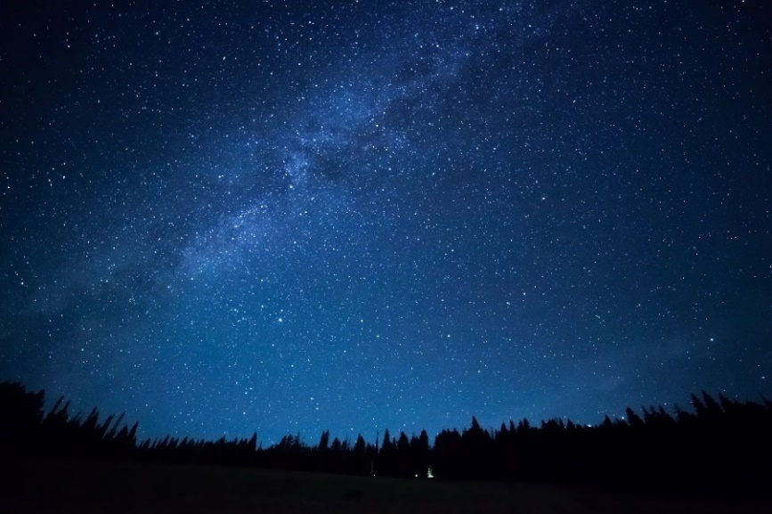
If we look at the creation and nature from the smallest to the greatest detail, we will notice nothing is there by chance, or just placed chaotically there. The nature (the one undefiled and untouched by man) has a certain order. Obviously, this nature bears the consequences of sin, but we can still see things working in a specific way there. Looking at the universe, we see stars, planets, a solar system are placed perfectly in a specific way.
It has nothing to do with an explosion or just throwing everything in a chaos. Somebody with a mind having a design stands behind it. Even if we go to the smallest detail, microscopically speaking, we will see molecules and all other small particles are placed in order. This is also similar to how a solar system works—it explains that the same mind stands behind it.
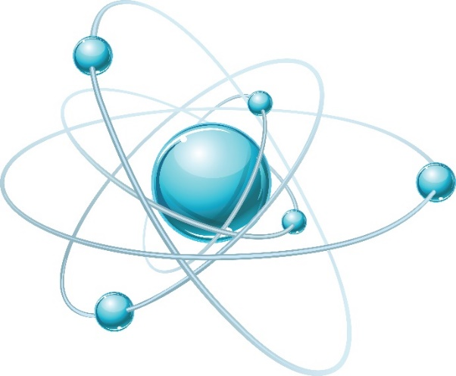

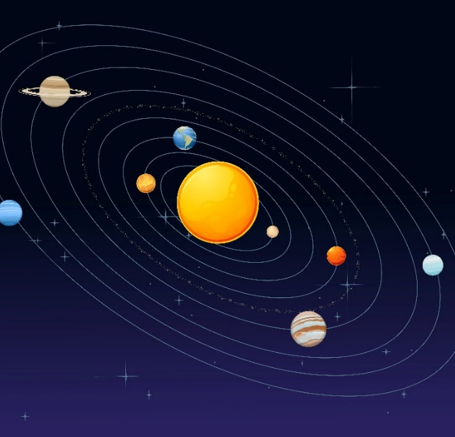
Each molecule is composed by atoms that hold each other. The last two pictures show the structure of an atom and our solar system. There are different kinds of atoms, but almost all of them are composed of neutrons and protons that form the nucleus and electrons that circle around the nucleus similar to the way planets do around the sun.

If I am not mistaken, there are cases where each electron has its own unique orbit the same as the planets.
We can see similarity here with the atoms, which in their structure look like a mini model of what a solar system is. I am not saying the atoms are small solar systems, but we see God’s genius design and creation by the way they are made. We see the same mind has created all of them, from the smallest to the greatest detail.
Looking at the chemical elements, is the same. They also have an order. If I’m not mistaken, most chemical reactions, poisons, and damaging corrosive materials exist because man placed them out of their natural place and order. But all this and other wrong things are caused by another greater disorder called sin. Looking at all the creation, those who are really gone in disorder is us. The humankind. And obviously this sin, this disorder brings consequences to everything else.
“For the creation was subjected to futility, not willingly, but because of Him who subjected it in hope; because the creation itself also will be delivered from the bondage of corruption into the glorious liberty of the children of God.” (Romans 8:20, 21)
God in His nature is the one who wants to fix this. He wants to fix everything. We can’t imagine sometimes what He can bear until He accomplishes that. We often can’t realize it, and we see things from our perspective, not being grateful enough. I don’t know if we will ever be in this life. I mean to be ever grateful enough, or be able to know, to understand all the reasons for being grateful. Thanks to God for the reasons He already made us to know. There is so much to be grateful for. I’m saying this because for God to fix what is wrong, He can just take it away from the picture and rebuild another one. But what He did instead was in our favor.
“I will strike them with the pestilence and disinherit them, and I will make of you a nation greater and mightier than they.” (Numbers 14:12)
He said this to Moses concerning the nation of Israel that kept on sinning against God, but after he pleaded for mercy, He left them and gave them another opportunity.
Look, there is a balance in nature, the universe, and the whole creation. The balance there just confirms about the character of their Creator. If I paint a picture and use a certain method or color, it will reveal my personality. It is because I like it, or I have that personality. Same is with God. The difference is that He is not a man like us. He doesn’t change His opinion.
He is not influenced by anything. He doesn’t have a “bad day” as we do. He doesn’t wake up and decide something, and the next day wakes up again and changes opinion. He is immutable, He doesn’t change.
As the Bible says in James 1:17, “Every good gift is from above, and comes down from the father of lights, with whom there is no variation or shadow of turning.”
So, His opinion toward sin is always the same. We see He didn’t change from the Old to the New Testament as someone might state. As Jesus said: “Do not think that I came to destroy the Law or the Prophets. I did not come to destroy but to fulfil.” (Matthew 5:17) What changed then?
He is for balance, for order. And if something goes out of that balance, He wants to fix it. This is in His heart. As when someone brakes something, he must pay for it. In this case we broke. Not just something, but many things. To bring a balance, He had to let us pay, but instead we see the Son did it for us on the cross. This is the reason why those who believe have their sins redeemed.
God judges the entire universe as Job 22:12, 13 and 25:4, 5 say: “Is not God in the height of heaven? And see the highest stars how lofty they are? And you say, ‘What does God know? Can He judge through the deep darkness?” (Job 22:12, 13)
“How then can man be righteous before God? Or how can he be pure who is born of a woman? If even the moon does not shine, and the stars are not pure in His sight,” (Job 25:4, 5)
We need to look at something here. He does all of this not just because He decided. He doesn’t decide this. It is hard to imagine, but it is so. He is the greatest being, He doesn’t have a measure, nor age. He takes everything. He is infinite.
“For in Him we live and move and have our being, as also some of your own poets have said, ‘For we are also His offspring.‘“ (Acts 17:28)
Yet He is not as we imagine many times. When somebody just decides something, this many times is based on His likes and preference. For example, when I decide not to eat something, most times, it is because I don’t like it. Yes, in another case, if I am starving, I can make a compromise and eat it. But it is not like this, when is about someone’s nature or being. When something is so awful to us, not because we just decided so, but naturally, by instinct we can't handle it. Then there is no question, we can’t stand it. It is a reaction that takes a place.
In the same way, justice is part of God’s nature. If we go through a place with a rotten smell, we will automatically turn our head away, we will try to avoid it or remove it. We can stand it for a while, but eventually remove it. This is how God looks at sin. He is so just and righteous in His nature that He has to fix it. Takes the time that will take, He will fix it. The reason for which He doesn’t bring this perfect justice now on the earth is because He decided to accomplish it through His Son.
That’s why He has patience with us and everybody. Because He wants people to repent. If He had brought a perfect justice now, no one would escape, but because He is patient, He gives us opportunity.
For this reason, the Bible tells us not to judge, not to revenge, to turn the other cheek. Because according to His standards we are not better, everyone deserves judgment. And we cannot say God is righteous and just because of a mere choice He made. He is not a man like us. That’s why it is not just because of a decision that He took. He is righteous and just because this is in His nature. He is like that. He is justice. No one can stand against Him or discuss with Him about that.
We can rather say that to show mercy, to send His Son for us, so that we can have this opportunity, was a choice He made. Without taking His righteousness away, because justice was served on the cross at the end. His Son took the punishment. And if we believe we enter into this promise.
All of this should take away the thought in us that God sometimes is cruel and prevent us from thinking or imagine Him as a mere man that takes decisions based on what He likes or not. He is like a being that takes everything. He is everything we see, feel, and move in, and no one can escape Him. He might be far from us in terms of His holiness, but in the same time, He is closer than what we can imagine, because He is everything around us. And He cannot stand at all this, He wants and must fix this sin.
He doesn’t have anyone to answer or submit to, but in a way He submits to Himself, to His laws! He is conditioned by that, because He cannot deny Himself. (2 Timothy 2:13)
Thinking about this, it comes to my mind about the laws that certain ancient kings were having. They were irrevocable. Meaning that once the law was given, it couldn’t be changed. Even the kings were submitted to the laws themselves had established. They had to follow them. Same as God. His laws, established by Himself are irrevocable. They are eternal. Jesus said that heavens and earth will pass away, but His words will remain for eternity. And these laws are established by God, because of His nature, because of what He is.
So going back to the conversation, someone had to pay, to fill this empty space or cross in our case. All of this to bring back the balance.
That’s why the Son of God came. To die for us, for those who believe, so that we mustn’t pay. God had a mercy. Someone still had to pay and die because this needed to happen to fulfill this. He couldn’t just forget about the sin we committed, even if He wanted to. Anyway, He tried to do something about it. The best He could. And He compromised Himself. And decided to suffer that punishment. This is an amazing love! Because He also could’ve just let us pay and everything would be fine with Him. He didn’t have anyone to answer to. And this was going to be still right. What He did was still righteous, but with the only difference that He paid. Sometimes we just don’t realize the grace we have; the opportunity and it will be difficult to realize all of it in this life. Even if we are safe and reborn. Then we will just have a small part of the whole picture. That is obviously good enough and can make us grateful. Sometimes we even dare to rebel or murmur in our hearts that God may forgive us and reveal more of His grace and what He has done for us. And I’m saying this to the believers as well.
We need to know that what He did was purely for love because even if He wiped us away was still going to be right, it was going to be something just. But He didn’t. Here is where His compassion came, wanting to give us still opportunity.
He could’ve wiped everything, but instead He sent His son. He took the punishment that was needed to be given, because by nature any sin needs to be repaid, justice needs to be served. His justice and punishment in this case can be defined as a reaction, almost a natural reaction, because this is obviously in His nature. Everything works in this way. 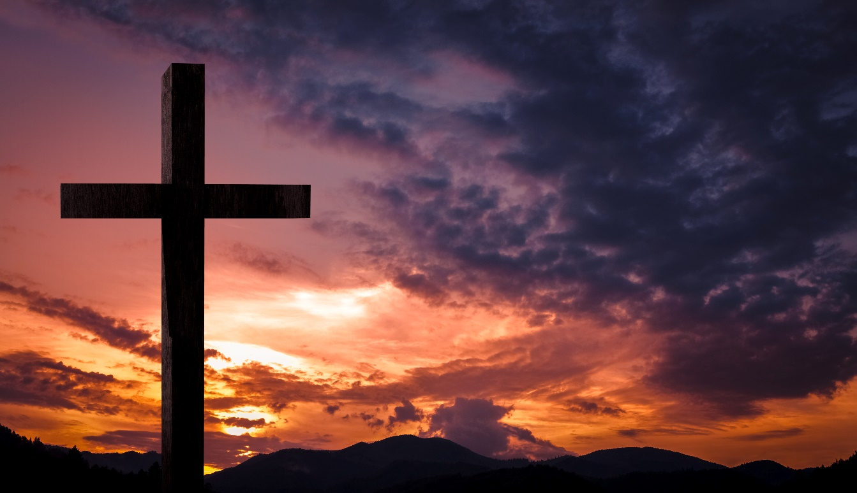
Because of His SON, God doesn’t react with us according to what we deserve. Because He reacted in that way towards the Son on the cross.
For some, God doesn’t react in this way because they have already accepted and believe in His Son. To others, because He has given them time to repent. And all of this because of His Son. Do you remember the parable of the barren fig tree?
He also spoke this parable: “A certain man had a fig tree planted in his vineyard, and he came seeking fruit on it and found none. Then he said to the keeper of his vineyard, ‘Look, for three years I have come seeking fruit on this fig tree and find none. Cut it down; why does it use up the ground?’ But he answered and said to him, ‘Sir, let it alone this year also, until I dig around it and fertilize it. And if it bears fruit, well. But if not, after that you can cut it down.’” (Luke 13:6-9)
Well, this parable is for us... We've been given an opportunity, a time to accept Him. That’s why the Son is so important, that’s why the believers are called Christians and the Bible is so focused on Him. Because if we are even alive today is because of Him. We can compare the vineyard owner to God the Father and the keeper of the vineyard to the Son. The fact he listened and followed the vineyard keeper’s advice shows that the Father and Son are one and the same person but expressing and manifesting different parts of God’s attributes in this situation. The Son shows the mercy, and He came on the earth to accomplish the mercy and the opportunity God wants to give to the humanity. This is the one year (that is just a symbolical) given to the tree to see if it will give fruit after the special care given to it. The special care given to it by the Son. The owner of the vineyard represents God the Father and His ultimate justice that will be given one day.
We can see the reason for the Trinity in this parable which gives an importance and exalts all three of them. The Father, the Son and the Holly Spirit, because they are one. And we see the “natural” reaction of God toward everything. Remember that He is not only extremely great (even giving Him this attribute, it would be little), but He is everything. There is not even a small place for discussion regarding His authority.
“God, who made the world and everything in it, since He Lord of heaven and earth, does not dwell in temples made with hands. Nor is He worshipped with men's hands, as though He needed anything, since He gives to all life, breath, and all things. And He has made from one blood every nation of men to dwell on all the face of the earth, and has determined their preappointed times and the boundaries of their dwellings, so that they should seek the Lord, in the hope that they might grope for Him and find Him, though He is not far from each one of us, for in Him we live and move and have our being, as also some of your own poets have said, 'For we are also His offspring.’ (Acts 17:24-28)
Many evolutionists through time have attributed “reaction” or development of things due to evolution. And yes, some things really react in certain conditions. With this I am not supporting the theory of evolution, but this to me only proves that God is there. That there is a greater mind behind all these variations, reactions or the way things work in the nature, as we see everything there reacts intelligently. God is working in this way. As different elements and things in the nature react in a certain way, so in the same way God reacts in a certain way with the sin.
And we can’t oppose ourselves to Him or the way He wants things. We are nothing out of Him, we can’t make it. It is like a fish opposing itself to water, or bird to air. In the same way we are created for Him. We can only survive now, and we still carry on because we are covered by this cupola of time of grace, but this time is running out. And we need to answer to what we are called for, to what we are created for—to worship Him, receiving Him first in our hearts. There is a lot to be thankful for, speaking mainly for this reason and topic. We hope and pray God can show and make us understand all this about His sacrifice more clearly.

