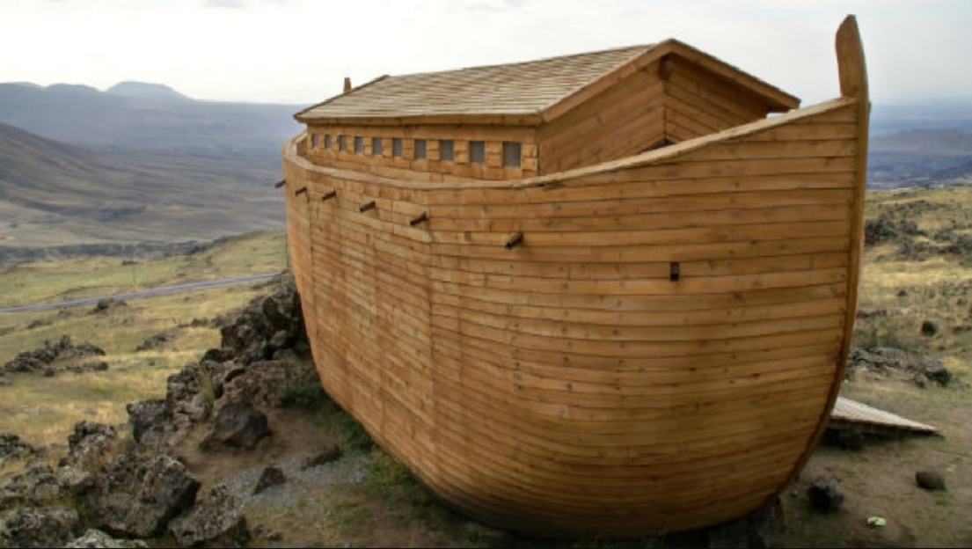
After meditating on the situation of the corona virus, an example came to me that I wanted to share about. We look at all precautions that are been used in these times with the virus as wearing a mask, being at the distance from each other etc. Just think that when everything started there were persons that didn’t even believe all of this was real until the virus didn’t get to them. In the very beginning in some places people would look at you in a weird way, as almost a crazy person because you were wearing a mask. With all of this we just see that the man by himself doesn’t listen to warnings. He likes to think that trouble will never happen to him, that everything will be fine, no worries. Especially in the first months when this situation happened, the phrase “Everything will be fine“ was displayed all over. But this phrase is not the one that we need to get hold on, especially the believers, because what we really need to hold on is Jesus and our hope must be in Him. I personally also hope that things will get better when a trouble comes, but this kind of hope mustn’t be everything for me.
So with this situation we can see how our nature is. And I wanted to use this just as an example, because as man usually doesn’t listen to warnings for anything might be, in the same way doesn’t listen to the warnings of God. The warning of judgement for example. “And it is appointed for men to die once, but after this the judgement“ Hebrews 9:27
Generally this particular part of which the Bible speaks so much about, escapes from people’s minds. At least from what I see. Some people just think that God will give you a better life, will prosper you, you will have a happy marriage, good family etc. All of this is fine and it can happen, but God is not warning us and telling us to obey Him, because otherwise we will not have those things, but He is warning us for the judgement that’s about to come. How to escape it, how not to be judged with this world. It is only through the blood of Jesus. Only through receiving His forgiveness. When I am speaking for the judgement, I am not speaking only for the end times, but for the judgement that everyone will face one day after finishing His life here and I am not saying that whoever is cautious for this corona virus will be cautious with what God says. I am just using this situation as an example.
Let’s see the story of Noah. Building the ark on a dry land with probably no signs of rain around. Surely for the people from that time he was considered a bit crazy. Until the day when the flood came. Surely he was warning them. Same as the Christians today. Their job is to warn the people about the judgment, that one day everything will finish and they will have to face their Creator and give an account for their life. And these Christians are also considered as crazy from this world. But nevertheless the message is been preached . “Everything will be fine“ people say, “It is not true, it won’t happen to me.” This is the self confidence we are talking about and this kind of confidence is false. As that man saying: “Soul, you have many goods laid up for many years; take your ease; eat, drink, and be merry.“ Luke 12:16-21 And he didn’t know that the very same night his soul was going to be required. And this is how man in general is. He needs a miracle in his life, so that he can pay attention to the warnings God gives him. When I started wearing a mask because of the virus and someone was asking me why, I wanted to answer that I am one of those crazy people who listen to the warnings. And in the same way we need to do with God’s words. If paying attention to something you can see is difficult sometimes, just imagine how is for man to listen and obey and be cautious for something like the judgment of God that he can not see yet. That’s why faith is needed and a conviction from God.
I remember some of these prophets from the old testament that had to do something just to set an example for the people, so that they can understand God’s word. I was almost feeling like them in those days and I wanted to say to the people: “In the same way as I carry this mask, because I want to be cautious for this virus, you also have to be cautious to the God’s word and listen to it, so that you can escape judgement.”
With all of this I wasn’t referring just for the situation with the virus, but I just used it as an example, because it reveals the state and the attitude of the human heart in general. We always think that we are the last ones on which something can happen and even if we know God’s word, we always want to leave it aside and deal with it another time. We wait for something to happen and then we start reacting. Well, I think that it mustn’t be always in this way. We need to react in time to the warnings of God. There is the parable of the barren fig tree that we find in Luke 13:6-9 that tells us about a fig tree not bearing a fruit and his owner wanting to cut it down, but the keeper of the vineyard stopped him by proposing him to give the tree another chance for a year more by taking a special care for it. The keeper of that vineyard was Jesus and we are that tree. We received an opportunity by Him to give fruit by repenting. He gave us that additional time of grace. We can have a look on how that situation in which Jesus told the parable started.
“There were present at that season some who told Him about the Galileans whose blood Pilate had mingled with their sacrifices. And Jesus answered and said to them, “Do you suppose that these Galileans were worse sinners than all the other Galileans, because they suffered such things? I tell you, no; but unless you repent you will all likewise perish. Or those eighteen on whom the tower in Siloam fell and killed them, do you think that they were worse sinners than all other men who dwelt in Jerusalem? I tell you, no; but unless you repent you will all likewise perish.”
He also spoke this parable: “A certain man had a fig tree planted in his vineyard…” Luke 13:1-6
We see that it was referred to Jesus that something wrong happened to certain people. They probably told Him that thinking that because of their sin, those people have perished in that way. Jesus told them instead that all the people including them are sinners and if they are alive and no trouble had happened yet to them, it is because of God’s mercy. With two words Jesus was telling them to be aware, because in any moment anything can happen and they need to react on God’s warnings and to repent. After He started telling them about the parable of the barren fid tree. It is not because of our own confidence that we stand today, but of His mercy. And this parable tells us that this time is for us to repent and it is running out, meaning that one day it could finish. People in general think that anything bad will happen to them and they are in a perfect security. Yes, this can be right, but we need to trust anyway in God’s word, because one day we will face in one or another way God’s judgement. We won’t be able to withstand trusting in our own security and confidence. We ill be able to stay in confidence there only by the blood of the Lamb, only by faith in Him.

