What can we do to please God? How can we attract His attention? These are been questions and tasks that since olden days have been in man’s mind too accomplish. We as people always thought that we can please God, because deep inside we know that something is missing in us and we are kind of debtors. Yes indeed we are debtors because of our sin and because even though we as human kind have been rejecting God, He is still giving us the gift of life and the opportunity to repent and know Him. This is an opportunity that we need to take.
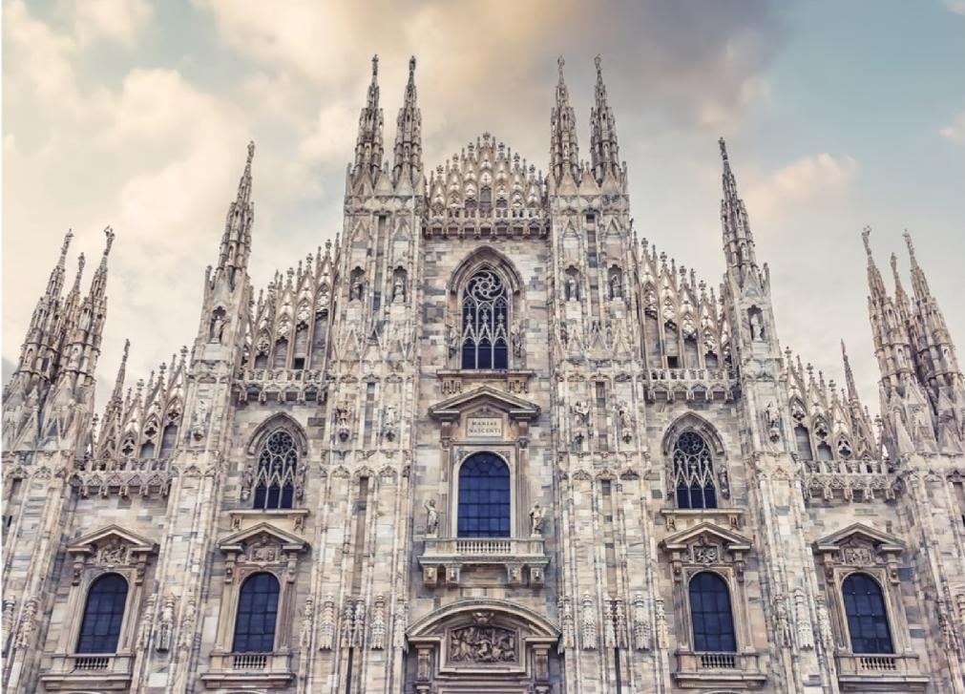
Some people are getting religious in a certain way and perform great works and sacrifices in order to please somehow God. Others are building great temples with great paintings and statues, made in the most perfect and detailed way a person can do. We are astonished by looking at these great buildings made by the most famous artists of the world. It is like we are trying to give our best to God. And indeed many people are trying to do that.
But do you think that God can be amazed by that? He is in heaven and we on the earth. He is the creator of the entire universe and our planet and us included. Can He be amazed or pleased by a nice built temple for example? Yes, we are amazed by that many times and if we say that He is so great, we can conclude that He deserves our best. But the truth is that He doesn’t need it and He is not and He can’t be pleased even by our very best. It is not only that He doesn’t want it, but He also can not.
We are speaking about a very high being here and not only very high, but the Most and only High. So, do you think that He can be really pleased by a statue for example or a nice building or something great done by someone? We can see the details with which some art works are done, but we can see the nature, the flowers, the insects, the animals and the creation in general.
We can see the details with which they are made. We can see this immense beauty, which can not be compared to the greatest artist ever existed on the earth.

By this we can conclude that He can not be amazed by anything that anyone else can make or do. Why? Because He is the creator of all.
“Hear, O My people, and I will speak, O Israel, and I will testify against you; I am God, your God! I will not rebuke you for your sacrifices or your burnt offerings, which are continually before Me. I will not take a bull from your house, nor goats out of your folds. For every beast of the forest is Mine, and the cattle on a thousand hills. I know all the birds of the mountains, And the wild beasts of the field are Mine.
If I were hungry, I would not tell you; for the world is Mine, and all its fullness. Will I eat the flesh of bulls, Or drink the blood of goats?”
Psalm 50:7-13
Here in these verses we see that God doesn’t need our sacrifices or things we can do for Him. Of course that a christian is supposed to do works for God which glorify Him, but here it speaks mainly about what comes from us alone, from our human nature. The people from the old testament (the time in which this psalm was written) were used to perform animal sacrifices before God as it was something commanded from Him in the book of the law. What He was telling them here was that even though they did everything they could and made as much sacrifices as they can, it was still not going to be enough and He was actually telling them that He didn’t need those sacrifices. As something commanded, they had to do it, but probably the way and the attitude they were doing it wasn’t right as they probably were thinking that it was enough. Nothing we can do with our hands can be enough for God. Even today we have things commanded by God to do, but even doing them it is still not enough.
Yes, they could glorify Him, but we need something else with which we can really glorify God, and that is His Son. This is the only way we can really glorify Him. Here in this psalm it speaks about sacrifices people performed, but there is one sacrifice which is the greatest of all and that is the sacrifice of His Son. The only one which satisfies Him completely. Even the sacrifices which they performed in the old testament were just a shadow of what was about to happen. That’s why they were done at first place – to tell everyone that there was a sacrifice needed for the sin and that sacrifice was going to be performed one day. Christ is the lamb of God.
And what’s interesting, is that this sacrifice wasn’t done by us, but by Him. All of this exalts His name and this is the only way in which we can really go with reverence before Him and acknowledge His greatness. All the other ways in which we do things and we glorify ourselves by that are not right. We as believers are called to do things for God and to perform works for Him, but all of this, is in His name and through His power and we can not exalt at all from this works, because if it wasn’t for Him, we wouldn’t have done them. This is anyway for the believers as all the rest of the people need first to believe and repent so that they can know personally the sacrifice He did for them.
So, from all of this we see that the only way He is pleased is by His Son. By the sacrifice of His Son and Him living in us.
“And suddenly a voice came from heaven, saying, “This is My beloved Son, in whom I am well pleased.”” Mathew 3:17
When He sees Him in our life, He is pleased, otherwise all the effort we can do, all the best of us can not do that at all. We are speaking about the God of the universe here. We are not speaking about anyone. There are so numerous galaxies, the universe is so vast and we are so small. Just imagine if any of our art work can please Him or draw His attention. He is the creator of far greater things and the creator of us as well. We as people like to take the glory even if it is about something concerning God.
“But will God indeed dwell with men on the earth? Behold, heaven and the heaven of heavens cannot contain You. How much less this temple which I have built!” 2 Chronicles 6:18
Here we can see what Solomon said when he built the temple for God. It was the first temple ever built for God and it was really great for that time, but still we can see here Solomon acknowledging something very important. He saw himself as a mere man building a temple for such a great God and recognized that God doesn’t actually live in a temple and He doesn’t need it. Yes, it was a form that they had to give to the service they were going to give to God. A temple in which the presence of God was going to be manifested to certain chosen by Him people. And yet even in that time when those things were required, they still acknowledged that this doesn’t still glorify God, but they humbly had to hope for His mercy to show.
We can see how often Solomon mentioned the word mercy in his prayer and praises they were singing to the Lord. Because even though they built a great temple, they still needed His mercy. They could have just thought or said: Look at the great temple we built for you Lord! Now we deserve something from you. But it wasn’t in that way. They still needed the mercy of God as he can not be pleased just by what they did. That God may help us today to have the same attitude even if we perform works for Him and even if those works are led by His Spirit. Even in this case we would still depend on God and need His mercy. “Help us Lord to have always this humble attitude in front of You! The attitude that we can have only after realizing what you have done for us on the cross, as the cross was drenched with this humbleness.”
The only way to please Him is trough His son. It is the only way, because any other sacrifice, even ours if we want to mention it, wouldn’t please Him completely. Even our death can not pay or satisfy anything He requires, but when we speak about the Son, it is different as He is without blame. He is the only one without any sin. Because He has a completely godly nature. That’s why Him dying is having so much power. Enough power to save anyone believing in Him. That’s why His sacrifice could cover so many sins. If God accepts us today, it will be only because He sees His Son’s sacrifice in us. And not only that, but He is also helping us to walk righteously. The only works that can please God, even though they are not the ones that save us, but are performed with the purpose to glorify His name, are the works prepared before hand for us so that we can walk in them.
“For by grace you have been saved through faith, and that not of yourselves; it is the gift of God, not of works, lest anyone should boast. For we are His workmanship, created in Christ Jesus for good works, which God prepared beforehand that we should walk in them.” Ephesians 2:8-10
Here in verse 10 it mentions about works prepared beforehand for us so that we should walk in them. These are the only works that glorify God as they are performed through the Son in us. The other works instead, the ones mentioned in v.9 are the fruit of our carnal mind and efforts. Useless efforts we can say, as they are produced and performed by our strength. God accepts better what comes from Him.
“Now therefore, our God, we thank You and praise Your glorious name. But who am I, and who are my people, That we should be able to offer so willingly as this? For all things come from You, and of Your own we have given You.” 1 Chronicles 29:13,14
We see here the statement of David while he was inaugurating the plans for the construction of the temple which his son Solomon was going to build and the people willingly brought materials for it.
He says to God: “For all things come from You and of Your own we have given You.” He doesn’t state that he just doesn’t have anything now and that’s why he offers to God what comes from Him, but he rather states that we don’t and we can’t offer to God anything except what we have received from Him. Because this is the only thing that can please Him. David says: “For all things come from you…” Before saying this he gave thanks and praised His name exactly because of His precious gifts to them.

There is another example that we can see in a story in Luke 7:1-10
“Now when He concluded all His sayings in the hearing of the people, He entered Capernaum. And a certain centurion’s servant, who was dear to him, was sick and ready to die. So when he heard about Jesus, he sent elders of the Jews to Him, pleading with Him to come and heal his servant. And when they came to Jesus, they begged Him earnestly, saying that the one for whom He should do this was deserving, “for he loves our nation, and has built us a synagogue.”
Then Jesus went with them. And when He was already not far from the house, the centurion sent friends to Him, saying to Him, “Lord, do not trouble Yourself, for I am not worthy that You should enter under my roof. Therefore I did not even think myself worthy to come to You. But say the word, and my servant will be healed. For I also am a man placed under authority, having soldiers under me. And I say to one, ‘Go,’ and he goes; and to another, ‘Come,’ and he comes; and to my servant, ‘Do this,’ and he does it.”
When Jesus heard these things, He marveled at him, and turned around and said to the crowd that followed Him, “I say to you, I have not found such great faith, not even in Israel!” And those who were sent, returning to the house, found the servant well who had been sick.”
Luke 7:1-10
We can see in this story about a centurion, a man with a good position and authority in those times and how he approached Jesus. Interesting that people told Jesus about the good things that centurion had done for their nation like building a synagogue. Nevertheless he went to Jesus with a humble attitude telling Him that he wasn’t worthy of Him coming under his roof and that only a word was going to be enough. He also attributed to Jesus huge authority, (and indeed it was so) by saying that only a word said by Him was going to be enough. That’s why Jesus was impressed by his faith, but what was also important was that he understood that he is unworthy, even though the people thought he deserves something by the deeds he had done. We can notice that Jesus did not say a word, hearing what the centurion had done for the Jewish nation by building them a synagogue, because this wasn’t actually important to Him. What was important was the way the centurion believed and the humble attitude he was having by not feeling worthy. He acknowledged himself as not deserving, meaning that even if he built a synagogue, he still considered that God is not satisfied just with that. And indeed He was more interested in the faith and the submission the centurion showed.

“God, who made the world and everything in it, since He is Lord of heaven and earth, does not dwell in temples made with hands. Nor is He worshiped with men’s hands, as though He needed anything, since He gives to all life, breath, and all things. And He has made from one blood every nation of men to dwell on all the face of the earth, and has determined their preappointed times and the boundaries of their dwellings, so that they should seek the Lord, in the hope that they might grope for Him and find Him, though He is not far from each one of us; for in Him we live and move and have our being, as also some of your own poets have said, ‘For we are also His offspring.’ Therefore, since we are the offspring of God, we ought not to think that the Divine Nature is like gold or silver or stone, something shaped by art and man’s devising.” Acts 17:24-29
We see from this scripture from the book of acts, said by apostle Paul when he was addressing the people from Athens telling them to worship the unknown God, the one who created all and everything we move in and we live in. He was pointing to reveal this part of the attributes of God to them, the one of His omnipresence and omniscience as they had many and different gods and each one of them was having a particular part or function, but the God that we worship is the one that is a creator of all and stands above everything and He is really worthy of receiving all the praise and worship. He also said that God does not dwell in temples made with hands as He is not worshiped with man’s hands as though He needed anything since He gives breath and life to all.
That’s why even if today we see and marvel to temples and churches made and crafted by the most skillful artist of the world and we remain without breath looking at them sometimes, we have to know that God doesn’t actually marvel at that and what He makes and comes from Him is much more beautiful and mightier than that and can not even compare with anything else on the world. Just imagine the details and the beauty with witch the creation is made. Just look at a flower for example and see how perfect it is. Which sculpture or image made by man can be compared to His creation? To this we can add the mightier of our works and deeds. Which one can be compared to His work of redemption offered to mankind. It can’t be even mentioned any comparison we can make with it.
All of this is for us to understand and realize that God only deserves worship and the only way for us to do that is through Him. This gives us even a greater reason to exalt Him. Because if it wasn’t for Him we wouldn’t be able to do none of this. We are also gifted with different abilities and we can do things for His glory, but the key is to be submitted to Him and to look for His guidance to do that. It is through His Spirit. We can not worship Him in our own way, even though it can seem well done and performed perfectly. The right and true perfection comes from Him.
“For of Him and through Him and to Him are all things, to whom be the glory forever. Amen.” Romans 11:36

