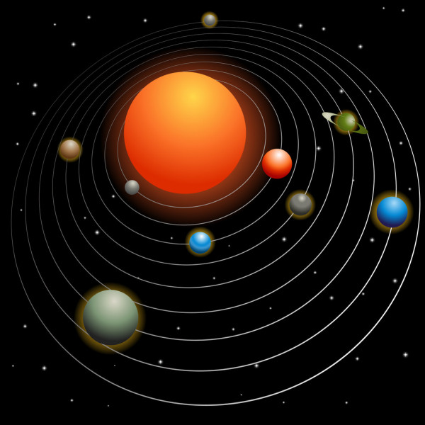
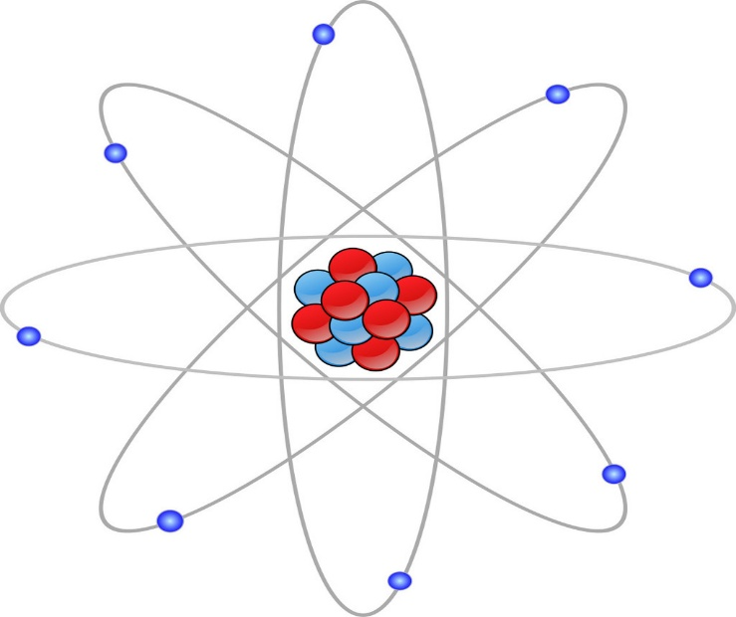
Since we know and believe that God is the creator of everything, then we need to know that we deal with really awesome and great God. Our mind cannot comprehend really His greatness or not even the greatness and the measurement of what He has done.
“For since the creation of the world His invisible attributes are clearly seen , being understood by the things that are made, even His eternal power and Godhead, so that they are without excuse…“ Romans 1:20
Here in this verse we see that we can see God trough His creation. It testifies about God. When I see a beautiful clean sky with stars, my faith is inspired because I see the greatness of God. We see Him in His creation, our Creator comes to our mind when we contemplate His creation. Anyone would admit (even the most skeptical person), that there is something that goes further, something more to it. Especially when we look at the sky with the stars into it. We get lost into the greatness and the depth we find there.
Yes, people marvel at the creation, but what we need to marvel most at is the Creator. And the Bible says that He is the creator of heavens and the stars. Psalm 19:1 says that the heavens declare the glory of God and the firmament shows His handiwork. Only in the milky way (the galaxy where our planet is) is estimated to be found between 200 and 400 billion of stars. Consider only that our sun is one of them, because our sun is a star. And not only this, but there are 100 – 200 billion other galaxies in the universe, some of them bigger than our milky way. And this is only what our telescopes can get.
All of this means that we really believe in a big and great God. And the Bible mentions that He created heavens, the earth and the stars. A publication I read once was saying: “The universe is already far too big to understand. But scientist just found that it’s actually much bigger than we’d previously thought.“ And these facts are just from what we can see, observe or perceive, but further than that we don’t know. And we are so focused to discover a planet or outer form of life when we don’t look at the bigger picture and find the Creator of it.
In Psalm 8:3,4 we read: “When I consider Your heavens, the work of your fingers, the moon and the stars, which You have ordained, what is man that You are mindful of Him, and the son of man that You visit Him?“
So here we clearly see, that He is the Creator of the heavens, the stars and everything up there – constellations, galaxies, etc. and we see a perfect order, a perfect system that works in the same way as another part of the creation. Like the smallest particles as the atom for example. We see in its structure electrons turning around the nucleon that is the center of the atom. And this is pretty much the same system, the same way as planets turn around another body as the sun for example. And there are other constellations working in the same way. So here we see the same mind standing behind it.
We see as well the huge number of all the galaxies, the greatness of God and how small we are. And we ask how is it that such a great God cares for such small creatures, or such a small part of the creation as us?
The answer we can find in Luke 16:10 “He who is faithful in what is least is faithful also in much, and he who is unjust in what is least is unjust also in much“. We have to know that when God says or commands something, He is the first one to accomplish it, (unlike us) and that’s even His nature. His nature is completely aligned with His word, with what He says to be done. His word is expression of Himself.
For example – if He tells us to love, it is because He loves, if He tells us to be righteous, it is first because He is righteous, and if He tells us to be faithful with the least thing, it is because He is as well. God is faithful with the least thing, even with the smallest part of His creation. He looks at the details, and that’s why he looks at us. That’s why He doesn’t only look at this planet called earth, but even looks at each person living in it. The question is that out of all the creation (as far as I know) it is us that went astray, and out of order. And He wants to fix this, He wants to take care of it. He is for this order. It is in His nature. He wants to put everything in its place, in the right way. And He goes even for the details. That’s Him. He gives it importance. We wouldn’t. We would care just for what is greater or we consider more important.
That’s why He cares for one of hundred sheep and for one out of billion people. And even if you would be the only one living on this earth, He would still die for You.
And He could’ve just wiped away everything, because of our sin and condition, but instead He made Himself similar to us and came to die. Just imagine how small we are and how small is still our heart with every single feeling and thought in it, but still He cares about it. He is focused on it, He observes it.
His mind is so great, so big and powerful to be able to take so many things in. We can even see examples with the people in this world. Greater someone is, or higher ranking He has in some organization, then greater matters he is having to deal with. And usually the smaller matters he leaves to other people lower than him. A president of a country will maybe never care of who is cleaning the toilets in the presidency building, or who is the paper supplier for his printer for example. Isn’t the same with God. He looks and observers everything, with all details.
For Him the least person is of the same importance as the greatest. And in a way we need to be the same. Once I heard a man of God shared a word, saying that if you want to success with God you need to look at the details. In the things that sometimes may appear as less important, but have a value for God. Because that is the mind of God. How many times we can see in His word things like: “take heed that you do not despise one of these little ones…”, “Even so it is not the will of your Father who is in heaven that one of these little ones should perish.” He gives importance to the details, to the small things. And: “Are not five sparrows sold for two copper coins? And not one of them is forgotten before God.”
Here we see how deep His mind goes, we see how great His mind is. So if someone tells you: ‘You think that God would care for people so small and insignificant like us?’, you tell him that He will exactly do that. He cares for your life, if you’ve broken some of His commandments and the way you are walking before Him. He cares about you.
Obviously when we are saying that He cares about the details, we are not necessary speaking for material things (if they are not involved directly with His will), but for things related to His Spirit. Many times we need to be honest in the smallest matters as well (there is not such thing as a small lie) and give importance to the least of the warnings. “Dead flies putrefy the perfumer’s ointment, and cause it to give off a foul odor; so does a little folly to one respected for wisdom and honor.“ Ecclesiastes 10:1
And God didn’t only look at such small creatures as us, but even made Himself a man to be able to reach us and to die for us. And also to have relationship with us, to be able to feel what we feel. As the verse says: “Who, being in the form of God, did not consider it robbery to be equal with God, but made Himself of no reputation, taking the form of a bondservant, and coming in the likeness of men.” Philippians 2:6,7
And all of this He did so that He can get closer to us and create a bound, so that we can be able to accept Him in our life. So, what we need to desire is that we can be of those ones who believe and submit to Him.

