Are We in the End Times?

Are we in the end times? Yes, we are. But we need to understand what exactly the Bible means when it speaks about the end times. In some epistles, we see how the apostles were already using terms like the last hour, last times, etc. Why is that? Were they confused? Definitely not. If they wrote that, it means that the last times were already there.
When Jesus died and was resurrected, He marked the beginning of these last times, of this last opportunity God gave humanity through His Son. This means that the last times began at that moment already. The parable of the barren fig tree in Luke 13 explains it. “But he answered and said to him, ‘Sir, let it alone this year also, until I dig around it and fertilize it’ “ (Luke 13:8).
These were the words of the keeper of the vine to the owner. This keeper was Jesus, and He was pleading with the Father to wait before cutting down the tree. He was going to take special care of it. And today, we are living in this time of special care for us through His sacrifice. The only way we can bear fruit is through His sacrifice. That means we are living in this “last year“ figuratively speaking. When He shed His blood, this last year started. “He indeed was foreordained before the foundation of the world, but was manifest in these last times for you“ (1 Peter 1:20).
We see from this verse that the times Christ was manifest were called “the last times.” Looking as well at the seven seals in Revelation 5:8, which are considered the judgment on this earth that will take place in the last times, we have to consider that probably some of them have already been opened. What if some of the seals could have been opened a thousand years ago? We often used to think that if we see an end times sign, the end needs to come tomorrow, or in five years, for example; otherwise it’s not a sign. But have we considered that a thousand years for God is not a long time, and the signs can start showing long before the end comes? What is considered a long time for us is not long for God.
Leaning on this point, we need to know that there are signs accompanying the end times and others having to do with the great tribulation. I believe they are different. Pestilences, for example, have always been there, and of course, Jesus said they will be there in the last times. But the last times are much longer than we think. He also spoke of “wars and rumors of wars“ (Matthew 24:6). There have been some crucial wars in these past centuries, and one of them was the Second World War. We hope not, but additional wars will likely come. When Jesus spoke though of these wars in Matthew 24, He was probably also referring to the ones we have witnessed as the First and the Second World Wars
So the right question to ask is not exactly “Are we in the end times?“ but “Are we close to the great tribulation the Bible speaks about?” Because if we see the seven seals that the book of Revelations speaks about, we will see that the first six were hard, but the seventh (which I believe we haven’t experienced yet) is the hardest. That seventh seal consists of seven trumpets. They start sounding one by one when that last seal is opened.
When He opened the seventh seal, there was silence in heaven for about half an hour. And I saw the seven angels who stand before God, and to them were given seven trumpets. Then another angel, having a golden censer, came and stood at the altar. He was given much incense, that he should offer it with the prayers of all the saints upon the golden altar which was before the throne. And the smoke of the incense, with the prayers of the saints, ascended before God from the angel’s hand. Then the angel took the censer, filled it with fire from the altar, and threw it to the earth. And there were noises, thunderings, lightnings, and an earthquake. So, the seven angels who had the seven trumpets prepared themselves to sound. (Revelation 8:1-6)

In this passage, we probably see the great tribulation; when it begins, we will be left with a short time.
There are four ideas and points of view regarding the end times. They are Amillennialism, Postmillennialism, Premillennialism, and Dispensationalism. These ideas differ regarding their ideas on the millennial reign of Christ, the rapture, and the role of Israel at the end times. They all stick to the blessed hope that Christ will return, which is the most important. We mustn’t wonder why there are all these different ideas. It is because these events haven’t occurred yet, and we are just not meant to know everything in detail about what will exactly happen. Instead, we must focus on what is the most important – the return of Christ and be ready for it. I am just mentioning some of these points of view, although, I am not going to deal with all the aspects the teaching of Eschatology covers. I’ll try to be impartial on the object even though you’ll see me as more inclined to certain points of view than others. Still, I’ll try to exalt the most important of the end times topic – Christ and His message.
As we already said, there are various ideas about the end times that differ at certain points, but let’s look at two that differ from each other, and most of us hold onto one or another. One is that the end is too far, and probably all of these signs still need to happen, and the other one states that the end is now, and anything happening is taken as a sign that precedes the end. I am not against either one of them, seeing that the Bible says clearly that no one knows the exact hour, not even the angels or the Son, but only the Father.
The problem is that in general, people have been impatient with these end times prophecies. There was a time when each sign, natural disaster, or war was seen as a sign that the end was here already. Such interpretations led people to set dates and periods of time when it was going to happen. This can be dangerous, as we know that setting dates is not in line with biblical doctrine, and when these predictions don’t happen, it can lead to disappointment, discouragement, and a loss of faith. The events that happened were probably signs and things God had predicted, but again we need to know that He measures and sees time differently from the way we do, and the very end times are still preserved for the future. It is exactly as the Scripture says in 2 Peter 3:1-9:

Beloved, I now write to you this second epistle (in both of which I stir up your minds by way of reminder), that you may be mindful of the words which were spoken before by the holy prophets, and of the commandment of us, the apostles of the Lord and Savior, knowing this first: that scoffers will come in the last days, walking according to their own lusts, and saying, “Where is the promise of His coming? For since the fathers fell asleep, all things continue as they were from the beginning of creation.” For this they willfully forget: that by the word of God the heavens were of old, and the earth standing out of water and in the water, by which the world that then existed perished, being flooded with water. But the heavens and the earth which are now preserved by the same word, are reserved for fire until the day of judgement and perdition of ungodly men.
But, beloved, do not forget this one thing, that with the Lord one day is as thousand years, and a thousand years as one day. The Lord is not slack concerning His promise, as some count slackness, but is longsuffering toward us, not willing that any should perish but that all should come to repentance.

Since then, it was predicted that when people would not see the prophecies of the end accomplished, they would turn against God and become scoffers. We see this occurring in today’s days. But people with a solid foundation of faith know how to be patient regarding the prophecies and promises of God. And we need to understand that if the end isn’t here yet, it is because God is patient toward people and wants more of them to reach salvation.
On the other hand, we mustn’t despise the prophecies or discharge all of them, taking them as something futuristic only. We need to consider the book of Revelation and its prophecies. Many people might not pay attention to the events happening now and won’t consider them because, in the past, nothing significant occurred when similar disasters happened. But maybe all of these things are happening just to ring the alarm in our hearts that we need to be spiritually awake. And again, people measure the time of God’s promises and prophecies according to their own view and perspective of time, when we see that God has been faithfully accomplishing His promises and fulfilling His Word throughout time.
Another group of people states that the prophecies have been already accomplished somewhere around the first century AD at the time of the Roman emperor Nero. Such teaching is called preterism. Even though some prophecies might have been accomplished at the time of Nero in the first century AD, we need to see that not all of them were fulfilled at that time. There are events that still need to take place. “Now learn this parable from the fig tree: When its branch has already become tender and puts forth leaves, you know that summer is near“ (Matthew 24:32).
Jesus spoke this short parable to focus our attention on the events happening around us so that we can know when His coming is approaching. He didn’t give us a date, but He told us to be alert. And I think Christians can read the signs and see more or less when the time is close, but to say the exact date is wrong.
There is also disagreement in the Christian world regarding the rapture and when it will take place. Some people say it will happen before the great tribulation, and others say it will be after it. But do you wonder why there is such disagreement and why we cannot know for sure? Some things are just not meant to be discovered by us now because we need to be always ready, for we don’t know the hour. This is also the right attitude we can have in the faith, to be always ready and alert, because when faith is still, it doesn’t grow.
It is also possible that the end might come when many different prophecies fit together, meaning that the events of the end times prophecies are going to be occurrences that probably have happened before. But when that moment approaches, we will see those occurrences happening more frequently than usual and at the same time.
Today we notice events like the plan for the reconstruction of the Jewish temple in Jerusalem, which for many, is a sign of the end times as some of the end time prophesies have to do with the Jewish temple. We also see groups and individuals in the world desiring to organize a “one world order.“ We hear about a change in the monetary system and wonder if this will have to do with the mark of the Beast. We observe more natural disasters happening and other indicators. But we don’t know how long it will take for the end to come once these events start taking place.
Maybe all of this is happening now to prepare us for the times to come. Even if this is not the very end (it might be, we don’t know for sure), the events happening now are an alarm to wake us up. Even if it doesn’t happen in this generation, the great tribulation and worse times than the present ones will probably occur during the next or the one after.
But how are people in the world from this present generation and those from the next one going to be watchful, as Matthew 24:42 says, if they haven’t seen us doing it? How will they know about what is to come? Some might say, “No, don’t worry, these things will come a long time in the future. We are fine now. Nothing to worry about.”
Even if we have sometimes said things like this, we shouldn’t always reason in this way, and we should reflect what the Bible says when we talk to people. The Word of God says explicitly that we need to watch—always. Our attitude should always be watchful alertness. It is something that was told to the early Christians, and it is still true today. Jesus commanded everyone to be watchful. This is the condition in which our hearts must be found, no matter the time in which we live.
Watchful alertness doesn’t mean that we start doing certain things more often than we used to (even if this is also a part of it). As it is written in the Song of Solomon 5:2, “I sleep, but my heart is awake. . . .” We see that this is a condition of the heart, and it can be achieved only by faith. In general, most of us Christians have been living in a very comfortable way (which is not always wrong) and we started focusing on having a blessed and prosperous life, which the Lord obviously can give us. But all this can cause us to forget certain principles and basics of the Christian life, such as living by faith and being watchful. “Watch therefore, for you do not know what hour your Lord is coming” (Matthew 24:42).
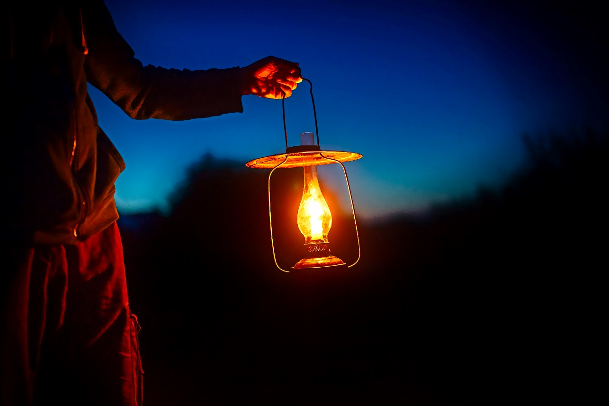
© [EvgeniiAnd]/Abode Stock

