There might be many different opinions on baptism amongst people. What we actually need to look at is the word of God. To be baptized doesn’t mean to be saved. It doesn’t mean that, but in a way I think that is completing the new birth and the salvation. It is something that is been commanded by our Lord and performed by the disciples and all the believers.
Peter on his sermon to those three thousand that got converted, said: “Repent, and let every one of you be baptized in the name of Jesus Christ for the remission of sins; and you shall receive the gift of the Holy Spirit.” Acts 2:38
I don’t think that by itself it is the most important, but the fact that is placed next to the repentance in the scripture means that is something to be considered seriously. Jesus told Nicodemus in John 3:5
“Most assuredly, I say to you, unless one is born of water and the Spirit, he cannot enter the kingdom of God.”
In one of the previous verses, in John 3:3, tells us about the importance of being born again, as this is the only way to see His kingdom, and in this exact verse it tells us in a more particular way what this new birth consist of. It tells us that we need to be born of water and the Spirit. About the Spirit we know that it speaks about the Holy Spirit which comes in our life as a sealing that we belong to Him and it comes after we accept Him and we repent sincerely. This is a very important part. The other one is to be born of water and this is having to do with baptism. I know that certain people interpret being born of water as a natural birth, (and they might be right in some cases), but to me is having a connection with the baptism.

Obviously there are cases when someone accepts Christ, then something happens to him, he dies and he didn’t have time to get baptized same as it happened to the thief being crucified on the side of Jesus for example. He didn’t have time for baptism, but he still got saved and went to heaven.
This anyway is not our case. In a normal life and circumstances, living as Christians and having Christ in our heart, we need to get baptized. This is also a kind of confession that we are making in front of the people and the church. We declare to the others that we belong to Christ, we confess it publicly, because they see us getting baptized or they know it at least. Meaning that they know that we took that decision to follow Christianity in a deeper way. It is like a testimony we are giving. We testify that we follow Christ and if it is not true, (because someone can get baptized without really following Christ and without comprehending the meaning of it), then we will bear the consequences. It must go with our lifestyle as well, because at the moment I declare something, I need to stand behind my words. Saying that I belong to someone, that I represent someone means that my life and behavior defines that person in front of those who see me.
Same as messengers sent by someone like a king or a ruler to another place or country. They represent him. The people from that place have probably never seen that ruler, but by His messengers they can have an idea how is that person. That’s why it is a serious task to do that and represent God. It can not be done in any way.
We represent God, the one who is above everything, the Creator of the universe and King of kings. And the word tells us that we need to confess His name, that we mustn’t be ashamed of it. By baptism we make a compromise with God, that we are going to serve Him, that we are going to seek His kingdom with everything and for a lifetime. And this kind of attitude is required from us by Him. Soon or later He demands that from us. He tells us to go deeper with Him into the faith. And this is a serious decision. It can not be taken lightly. And the only one who is able to fulfill this compromise or pact with Him is the one who is born from the Spirit. Because only His Spirit in us can help us to perform this, to be able to follow Him to the end. It might sound harsh, but this isn’t something to be taken lightly. Baptism can not be looked as a mere ritual, as something that everyone needs to do, because he goes to church or likes the service there. No. It is a compromise taken for a lifetime with God.
But this is also what He demands from us. To follow Him to the end. It might look so hard when someone didn’t experience His Grace and His forgiveness.

“Do not rush with your mouth, and let not your heart utter anything hastily before God. For God is in heaven and you on earth; therefore let your words be few.” Ecclesiastes 5:2
Even though He warns us not to say or make vows lightly, He wants us to get to that position, but trough Him. He can enable us to do it. We can not be just baptized with water, because we won’t be able to accomplish the vow we are making in front of Him and the others. Because at the moment we get baptized we are confessing that we belong to Him now, but how can it be, if we don’t have His Spirit in our life? We can not remain just with the baptism of His Spirit as well (which is very important, it is the main thing), because soon or later He will want us to compromise ourselves for life with Him.
He wants people who follow Him for a life, not people who take this as a fashion or something temporarily. They need to have at least that desire even if they don’t know exactly how everything will go. He can accomplish it in them. And we see in the scripture people like Peter who said that they will never deny His name, but after that they failed. The reason why, is that they didn’t have His Spirit yet at that time. (I am speaking about Peter denying Jesus and that happened before the Holy Spirit was given.) Our compromise or word in itself only, doesn’t accomplish His will.
I remember when I accepted Jesus in my life and received His Spirit. I was so full of joy and happy. I felt the burden falling off from me. I was seeing everything in a new way and light. But I remember that I still wasn’t sure if I was going to follow God for lifetime. I was just living and enjoying the moment. I remember as well that I was still committing certain “small” sins deliberately. I wasn’t so sure, so compromised. God was manifesting His Grace over me, but it was like I was with one foot in the world and with the other with Jesus.

It didn’t take long before I understood that I had to take a serious decision, to take the path to follow Jesus wherever an however He wants, with all my heart. This is when I believe, we can make a decision. It happens after we experienced something from Him, when we know clearly His Spirit and Grace. Before knowing that, in most cases it is impossible to take a decision. How can someone take a decision for something that he doesn’t know? How can he appreciate His mercy? Before that happens in his life, the only thing he can do is to try to inquire and set himself in a research for God.
So, I understood that I had to get baptized, I had to take seriously the path with Jesus. I remember that after doing that I became much more compromised and serious about my walk with Him and I stopped being in the world and in Him in the same time. The way I was looking at sin, changed as well. I became more cautious toward it.
It is like the situation of the children of Israel coming out of Egypt. What caused them to come out? What caused Pharaoh to release them? It was the last plague that was the angel of death crossing through the whole Egypt. We know that Egypt spiritually represents the world, the slavery of the sin and the Pharaoh represents the devil. The Pharaoh couldn’t bear anymore with the nation of Israel, especially after the last plague and thus released them. The last plague was the hardest as the angel of the death was going to pass across the land of Egypt and all the firstborns were going to die. All of them, beside the ones found in the Israeli’s homes, because they had marked their doorposts with the blood of the sacrificial lamb. (Exodus 12:1-30)
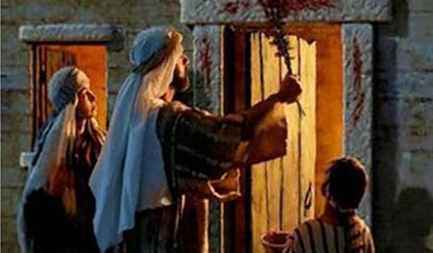

They were spared, not because they were more special or because they were His nation, but because of the blood of the lamb. As they got delivered and released from Egypt that night, we conclude that we need that blood to be delivered from sin and the slavery of this world. The sacrificial lamb obviously represents Christ who was crucified and shed His blood for us.
We need the blood of Christ, we need His forgiveness. Without that it is impossible. But we see as well that up to the point where they had to pass through the sea, the Egyptian army was still after them. Here it comes when I said that even after accepting Christ the world was still after me, that there were still desires in me and I wasn’t 100% sure whom to follow. There were still connections, robes that were tying me to it.

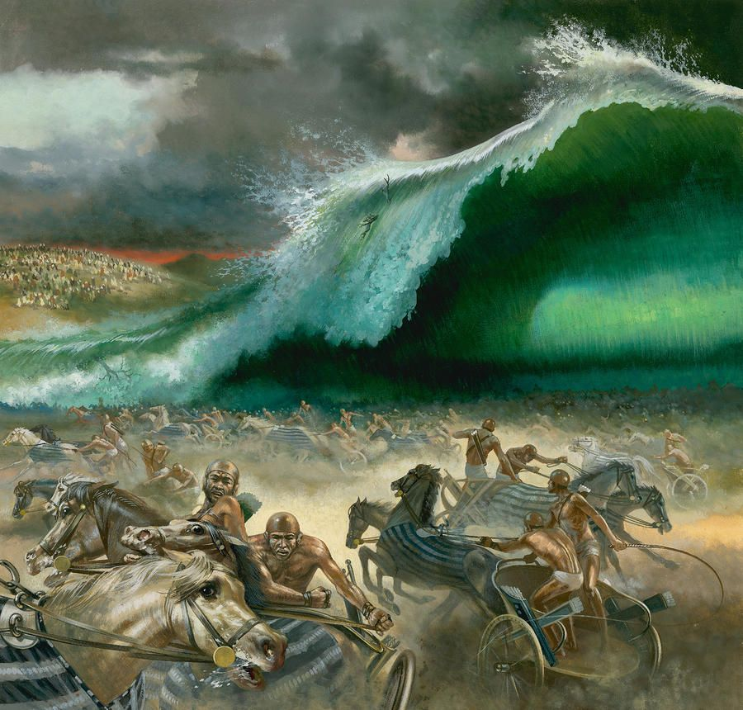
And after crossing through that sea, through that water that represents the baptism, they got delivered completely as the waters returned and covered the Egyptian army that couldn’t cross the sea and remained in its depth. (1 Corinthians 10:1,2) (Exodus 14:1-31)

It happened after taking that solid decision whom they were going to serve. It is quite easy when we have Christ in our life, it is complicated when we don’t. That’s why only water baptism doesn’t save us. It is wrong for people to think that they have something in them after being baptized, but it is effective when they have Christ in them and in this way the work of salvation of God in their life is complete. Obviously even after being baptized a believer will still struggle with sin and the enemy will still be attacking him, but now he doesn’t belong anymore to him, he is not a slave anymore, but belongs to God. And there will be a path to walk and follow with trials coming sometimes, but there is a victory in the One who overcame. He is faithful and He will accomplish His work in us.

